

PRACTITIONER JOURNAL OF MATHEMATICS AND SCIENCE TEACHERS (PJM&ST)
VOLUME 3, ISSUE 1, 2024

A PUBLICATION BY THE CENTRE OF MATHEMATICS, SCIENCE AND TECHNOLOGY IN AFRICA (CEMASTEA)

JUNE 2024

CENTRE FOR MATHEMATICS, SCIENCE AND TECHNOLOGY IN AFRICA (CEMASTEA)

P. O. BOX 24214-00502 Karen – Bogani-Karen Roads Junction,
NAIROBI – KENYA
Phone: +254-20-2044406; +254-0706-722697/0780-797648
E-mail CEO@cemastea.ac.ke
Websitehttps://www.cemastea.ac.ke/

PRACTITIONER JOURNAL OF MATHEMATICS AND SCIENCE TEACHERS (PJM&ST)

Volume 3, Issue 1

RESEARCH & DEVELOPMENT-KNOWLEDGE MANAGEMENT DEPARTMENT

All rights reserved
© CEMASTEA

About the Journal
Practitioner Journal of Mathematics and Science Teachers (PJM&ST) is a publication of the Centre for Mathematics, Science and Technology Education in Africa (CEMASTEA). It is a Journal for teachers and by teachers that aims at publishing original work in the form of theories, research, models, and experiences that teachers can draw from to support curriculum implementation and improve practice in Science, Technology, Engineering and Mathematics (STEM). This is in line with the aspirations inherent in the Kenya Vision 2030, particularly in the Education and Training sector of the Social Pillar.

In today's rapidly evolving world, STEM education cannot be overstated. STEM disciplines shape how we live and interact with our environment and fuel innovation and progress. The CEMASTEA Practitioner Journal of Mathematics and Science Teachers (PJM&ST) proudly presents a platform for sharing STEM research and classroom practices. The journal also provides teachers a platform to connect with colleagues from different schools and regions, fostering community and collaboration within the education sector.

STEM research is a gateway to understanding and addressing the most pressing challenges of our time. Through investigation and inventive thinking, STEM researchers unravel the mysteries of the universe, create groundbreaking technologies, and drive economic growth. This Journal celebrates the tireless efforts of teachers and teacher trainers who explore uncharted territories and redefine the boundaries of human knowledge in STEM education.

PJM&ST is a peer-reviewed journal that employs a double-blind review process. The following editorial Board members and technical officers support publishing the PJM&ST.

Editorial Board

Editor-in-chief
Mrs Jacinta L. Akatsa, HSC, CEMASTEA

Editorial Board and Reviewers
Dr. Mercy Macharia
Dr. Karanja Mutitu
Mr. John Makanda
Md. Rahab Chiira
Md.Clotilda Nyongesa

Editorial
Welcome to the Practitioner Journal of Mathematics and Science Teachers. Initiated by CEMASTEA, the Journal is dedicated to practitioners in STEM education and related subsectors to document and share their everyday experiences and pedagogical breakthroughs, including successes, challenges, and lessons learned, thereby creating a space for collective growth. Therefore, the practitioners whose articles are published in this Journal form a critical mass that continues to propel the practice of teaching forward. Each article represents a small but powerful step towards excellence. This Journal is, therefore a celebration of their efforts and achievements.

This Journal aims to facilitate cross-disciplinary dialogue and discussions, bridging the gaps between different STEM fields and inspiring new ways of thinking. In each issue of the Practitioner Journal of Mathematics and Science Teachers, you'll find articles that speak to the daily realities in our classes, schools and in teacher development programs. The Journal contains case studies that illustrate real-world experiences of practitioners, theoretical notions and ideas to in-depth analyses of emerging practices in STEM and related classroom practices. The overall aim is to provide our readers with relevant and actionable insights.

To enhance the richness of perspectives and strengthen the scientific community, the Journal is committed to showcasing the contributions of researchers from diverse backgrounds. A wide range of voices will create a holistic view of STEM research and its potential to address global challenges. As we embark on this journey, let us embrace the excitement of discovery, the power of collaboration, and the impact of innovation.

As you draw inspiration from reading the articles, kindly give us feedback that we could use to refine subsequent issues. Let us together walk the journey of making the Journal a beacon of inspiration for practitioners worldwide. We encourage readers also to write articles, as your contributions will make this Journal a dynamic space where knowledge is transformed into meaningful impact. Plans are in progress to transition the publication of the PJM&ST to an Online Journal System (OJS) platform. The International Standard Serial Number (ISSN) registration for the PJM&ST is in progress.

On behalf of CEMASTEA and myself, I wish you a happy reading of Volume 3, Issue 1 of the PJM&ST. I take this opportunity to invite all practitioners in the Education, Training and Research Sectors to support the PJM&ST by contributing articles for the upcoming Issues and Volumes. This third Issue of the PJM&ST is published on CEMASTEA’s Website and e-Portal.

Jacinta L. Akatsa, HSC.
CEO, CEMASTEA
Table of Contents
About the Journal 2
Editorial Board 2
Editorial 3
A Professional Development: Primary Teachers Integrate Computational Thinking through Learning2code 5
Dr. Mercy Macharia 5
Communities of Practice: A Breakthrough for Effective CBC Implementation at Junior School: A Teacher's Perspective. 11
Dr. Karanja Mutitu 11
Effective Teaching of the Periodic Table 18
Odeke Asangire Tophista 18
Let the Learner Ask: Redefining Question-Answer Teaching Method to enhance Meaningful Learning 23
Kennedy Musyoka Kivonya 23
From Resistance to Routine; Embracing Lesson Planning in my Teaching 29
Naima Adan 29
Learner involvement in preparing Resources for ICT Integrated Biology Lessons 35
Julianah Vore Mwanjelle 35
“Adventure with Nitty Gritty” Volte facing experience for 21st Century Learners. 40
Hilliard Peter Kiwaza Righa 40
Revolutionising Learning: The Magic of IBL-5E Instructional Model 46
Mbishei Motum 46
Whose Voice Does Matter During the Teaching and Learning of Mathematics? 51
Caroline M. Makato 51
Investigating Integration of ICT in Teaching and Learning Integrated Science in Kimilili, Bungoma Kenya. 58
Fredrick Sunguti 58
Applying the “SMART” Concept in ICT Integration for effective Teaching and Learning STEM 64
Faith Shali Mwamburi 64
What a Saviour! Time Takers can still make it in Life 69
Kisali David 69
The Performance Puzzle: High Achievers in Primary School and their unexpected Struggles in Secondary School 74
Ms Christine Adhiambo 74

Practitioner Journal of Mathematics and Science Teachers, (PJMST)
Volume 3 Issue 1, pp …….

A Professional Development: Primary Teachers Integrate Computational Thinking through Learning2code

Dr. Mercy Macharia
Abstract | Many teachers struggle to integrate Computational thinking (CT) and coding content in their classrooms. They often require training to employ computational tools that support CT and scientific processes. To this end, CEMASTEA staff developed an online professional development (PD), Learning2code program for Kenyan primary school teachers who engaged in learning how to code using Scratch 3.0. In this article I outline the implementation of the Learnind2code program over three weeks: one synchronous and two asynchronous. I share detailed descriptions of how the teachers leveraged the digital spaces, developed projects they can use in their classrooms, and presented them in the CEMASTEA portal. Sessions evaluation feedback from teachers revealed that teachers gained knowledge and skills in computational thinking and coding. They stated they can now confidently teach coding in their classrooms following the training. They also realized that coding can enhance learners' critical and problem-solving skills and make learning in science classrooms enjoyable. They designed projects that might be utilized in the classroom to help students better comprehend concepts like environmental preservation and climate change. Finally, I recommend other educators to adapt the Learning2Code program and help teachers integrate CT practices in science teachers' classrooms.  Keywords: Computational thinking, Professional development, Coding, Scratch 3.0, Learning2Code

1.0 Introduction
It is becoming increasingly important to give all students the chance to develop their computational thinking (CT) and computer science skills during their primary and secondary education (CEMASTEA, 2022; Jocius et al., 2021). This not only creates opportunities for students to engage in solving real-world problems but also has the potential to transform the classroom into a constructionist environment that positions students as programmers and designers of technology (Wilensky et al., 2014).
In Kenya, coding was first introduced in Grades 4 and 5, but it is currently taught in Grade 8 in the Comptency Based Curriculum (CBC). Given that computer science is an elective in Kenya's senior school pathway, its incorporation into Middle schools is very important (KICD, 2017; 2024). Coding proficiency is a necessary ability in today's technologically advanced environment. It is crucial to introduce coding throughout the early learning years because it introduces students to CT at a young age. To promote CT learning, a shift in professional development (PD), that supports teachers as CT learners and designers is required (Grover, 2021). Teachers need to learn how to use CT tools in the context of their subject's content, gain skills, and participate in constructionist design (Kelter et al., 2021). Without such experiences, teachers may struggle to teach computational lessons that promote constructionist, authentic problem-solving practices afforded by CT. In Kenya for example, teachers experienced challenges teaching coding in Grade Five (CEMASTEA, 2022). To overcome these obstacles, CEMASTEA regularly organizes teacher training on coding, such as the Learning2Code described in this article.
2.0 Learning2Code Professional Development Program
In a research carried out by CEMASTEA (2022) on situational analysis of teaching and learning coding in Middle School, it was observed that teachers needed support to teach coding. The research informed CEMASTEA of the need to train teachers in coding. In this article, I describe an online training program; Learning2Code that positioned Kenyan primary teachers as learners and codesigners of projects they could use in their classrooms as learning resources. Prior work has shown that engaging teachers in codesign can increase their ownership and technological pedagogical content (Cober et al., 2015).
The Learning2Code training was designed as a 3-week online PD program to help primary teachers learn to code and implement knowledge and skills learned in their classrooms. The training was scheduled between 3.00 and 5.15 pm for five days of synchronous sessions and 2 weeks of asynchronous sessions. The following content was covered: an introduction to coding; patterns and games (computational thinking); an overview of Scratch; animation using Scratch; games and graphics using Scratch; and Scratch Project. The interactive training methods used during the training allowed teachers to get hands-on experience with coding while creating numerous activities and projects (Table 1).
During the asynchronous sessions, participants attempted activities and projects posted in the CEMASTEA e-learning portal and were mentored and graded by a group of CEMASTEA National trainers (Table 2).

Table 1
Overview of PD Activities during the Learning2Code Program (Synchronous sessions)
Week | Monday | Tuesday | Wednesday | Thursday | Friday
1 | Training objectives and guidelines | Session 1: Introduction to coding | Session 2: Introduction to Scratch | Session 3: Overview of scratch | Session 4: Animation using Scratch
 | Pre-evaluation | Relationship between games and coding | Programming and coding | Interface | Backdrops
 | CEMASTEA portal | Computational Thinking | Coding Applications | Code blocks | Saving your project
 | Meaning of coding | Patterns and Games | Working with sprites |  | Take away task –scratch projects.

Table 2
Overview of PD Activities during the Learning2Code Program (Asynchronous sessions)
Week | Monday | Tuesday | Wednesday | Thursday | Friday
2-3 | Project 1:Ansychronous  Teachers were asked to create a storyboard for the following Pertinent and Contemporary Issues (PCIs) for animation: (i) Climate change; (ii) Affordable housing (ii) Care for the environment and animals (Or any other of their choice)
Project 2:Ansychronous
Teachers were asked to consider the Pertinent and Contemporary Issues and: (i) Design a puzzle game that promotes diversity and inclusion; (ii) Create a game that educates players about the issue of food waste challenge. (iii) Design a game where players take on the role of a cyber-security expert defending a virtual network from cyber threats; (iv) Create a game where players must navigate a world affected by climate change.

Project 3:Ansychronous
Teachers were asked: (i) to name one problem found in your environment and come up with a solution.(ii) to draw code blocks needed to solve the problem (iii) Using the the drawings, to find the code blocks on scratch and drag them to the code area(the codeblock should have at least one block from the Motion, looks, sound, events and control button) and (iv) to logically arrange the code blocks and make any changes you need to make.
3.0 Teacher experiences
In this section, I present teachers' responses from synchronous and asynchronous sessions. Synchronous sessions facilitated by the National trainers were evaluated and rated using a session evaluation tool that gathered quantitative and qualitative data. The projects teachers uploaded to the CEMASTEA e-learning portal served as the basis for assessing the asynchronous sessions.
3.1 Synchronous sessions
To determine the usefulness, aspects of both the quality of session content and facilitation were rated using the session evaluation tool. All the four sessions facilitated were rated above 4.0 on a scale of 1-5 which can be interpreted as good. Participants were further asked for reasons for the usefulness of the training. In the next section are some verbatim responses in favor of their responses:
They stated that they learned a lot during the Learning2Code program.

I have learned a lot about computational thinking, coding, and programming
In the beginning, I was green on coding and at the end of the session, I understood clearly what it is
At least I can define coding and programming. I know how my childhood simple games are directly related to coding and they make learning interesting although involving

Teachers stated that they can now teach coding in their classrooms
I have been wondering how I was to teach my lesson on coding Grade good science but today it has given me an insight
I can now apply coding to teaching

Importance of cording according to the teachers
It is useful in teaching and also interesting
Helps the critical thinking of the learners during the learning process
Coding helps in critical thinking and problem-solving.
Coding enhances critical thinking and makes teaching enjoyable.

3.1 Asynchronous sessions
During the two-week asynchronous session, teachers designed projects they can use in their lessons. These include projects learners can design to deepen their understanding of climatic change, and keeping their environment. Figures 1 and 2 illustrate examples of those projects

Figure 1: Planting trees to mitigate climate change project
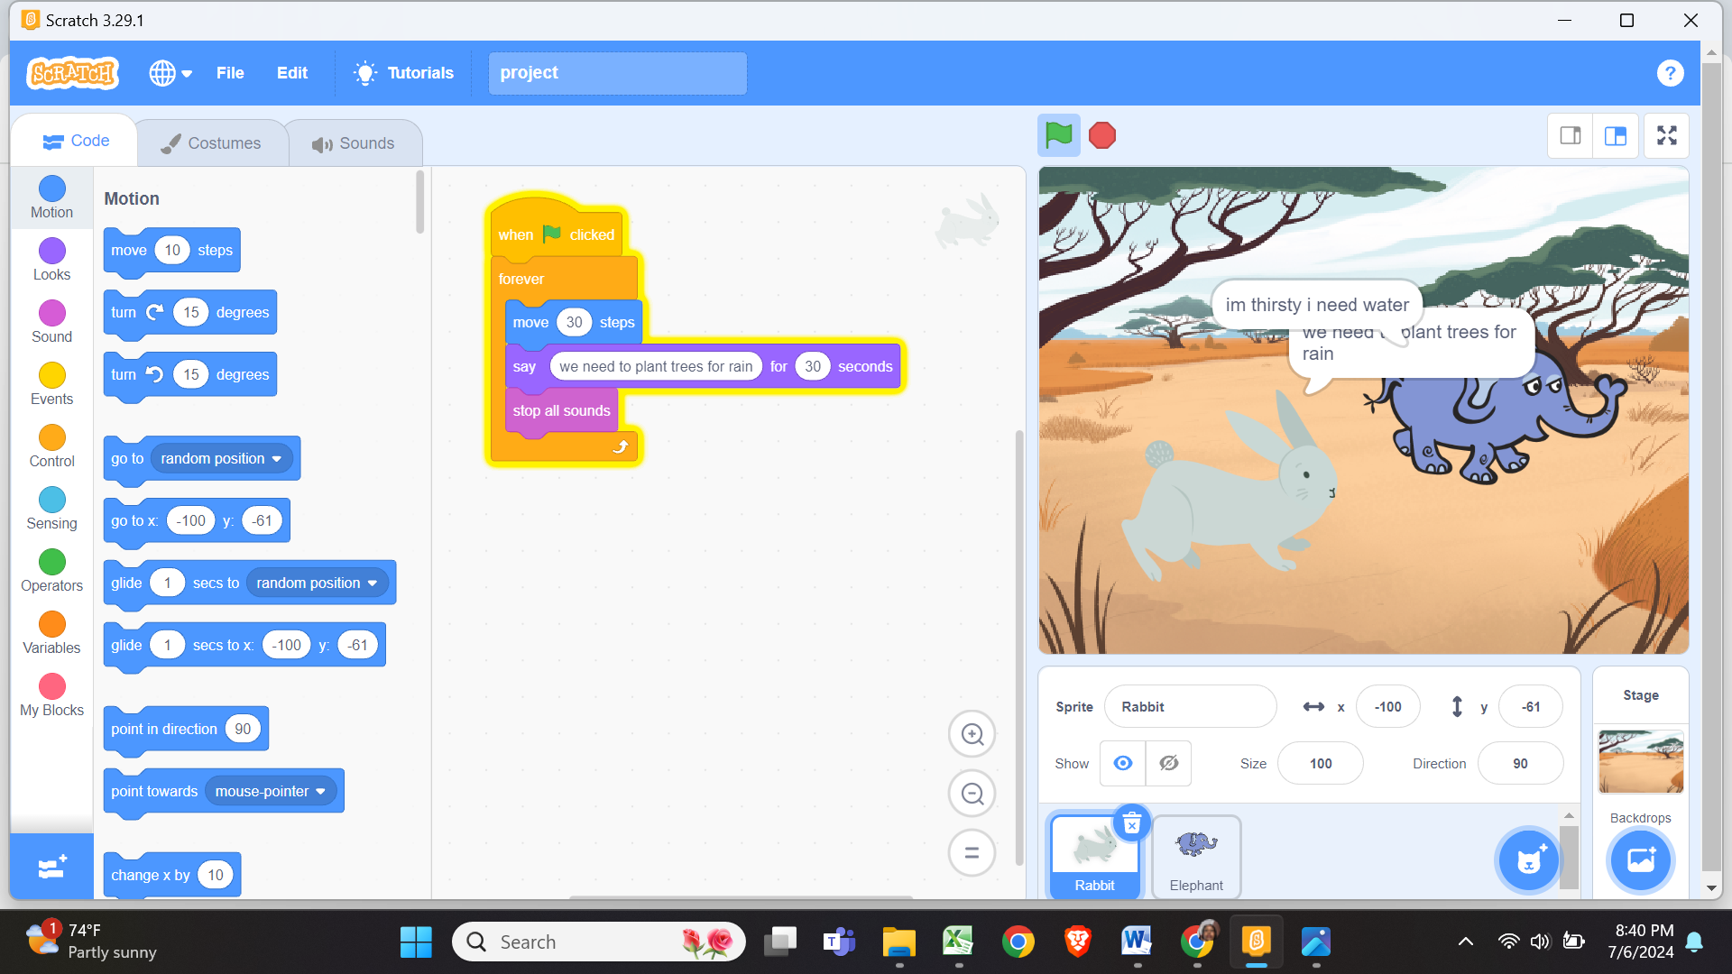

Figure 2: Care of the environment projects
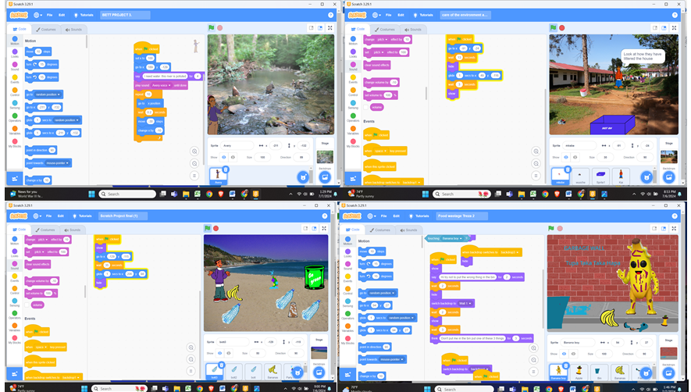

Conclusion
This article provides information on a professional development Learning2Code training involving Kenyan primary school teachers that researchers and teacher educators can adapt. In this article, I detail how CEMASTEA trainers leveraged digital spaces to engage teachers in three weeks of PD using online platforms. As a result, teachers participated as learners and designed and developed projects using Scratch 3.0 that they could use in their classrooms. Although the duration of the training was short, teachers appreciated the knowledge and skills they gained that could go along in improving their pedagogical content knowledge. I hope CEMASTEA will continue to work on the sustainability and scalability of this PD program to a bigger audience and that other stakeholders in education will join this endeavor.

References

CEMASTEA. (2023). Situational analysis on teaching and learning coding in Middle Schools in Kenya [Unpublished research report]. CEMASTEA
Cober, R., Tan, E., Slotta, J., So, H.-J., & Könings, K. D. (2015). Teachers as participatory designers: Two case studies with technology-enhanced learning environments. Instructional Science, 43(2), 203–228. https://doi.org/10.1007/s11251-014-9339-0
Grover, S. (2021, April 12). ‘CTIntegration': A conceptual framework guiding design and analysis of the integration of computing and computational thinking into school subjects. EdArXiv. https://doi.org/10.35542/osf.io/eg8n5
Jocius, R., O’Byrne, W. I., Albert, J., Joshi, D., Robinson, R., & Andrews, A. (2021). Infusing computational thinking into STEM teaching. Educational Technology & Society, 24(4), 166-179.
Kenya Institute of Curriculum Development (KICD, 2023). Rationalized curriculum designs. KICD. Nairobi Kenya
Kenya Institute of Curriculum Development (KICD, 2017). Basic Education Curriculum Framework. KICD. Nairobi Kenya
Kelter, J., Peel, A., Bain, C., Anton, G., Dabholkar, S., Aslan, U., ... & Wilensky, U. (2020). Seeds of (r) Evolution: Constructionism Co-Design with High School Science Teachers. Constructionism 2020.
Wilensky, U., Brady, C. E., & Horn, M. S. (2014). Fostering computational literacy in science classrooms. Communications of the ACM, 57(8), 24–28. https://doi.org/10.1145/2633031

Name: Dr. Mercy Macharia
Affiliation: CEMASTEA
Email: mmacharia@cemastea.ac.ke

Practitioner Journal of Mathematics and Science Teachers, (PJMST)
Volume 3 Issue 1, pp …….

Communities of Practice: A Breakthrough for Effective CBC Implementation at Junior School: A Teacher's Perspective.

Dr. Karanja Mutitu
Abstract | This study assessed the support systems and resources provided to junior school teachers in Nyeri County for implementing the Competency-based Curriculum (CBC). The study was anchored on the Diffusion of Innovations and Resource Dependence theories. The study used a sample of 30% of the teachers handling Pre technical studies and Agriculture and Nutrition in Nyeri County, comprising 62 teachers. The training areas covered during the INSET training were inquiry-based learning (IBL), communities of practice (CoP), ICT integration in learning, learning resources, Planning and peer teaching, and mentorship and career guidance. Despite receiving training on CBC, teachers found it challenging to implement the curriculum due to the limited availability of textbooks, instructional materials, and technological resources. The study also found inadequate infrastructure and inaccessibility to technology, particularly in under-served areas, to be significant hindrances. Teachers recommended targeted investments in mainstreaming communities of practice and digital learning platforms to support CBC implementation as the solution to effective CBC implementation. The Ministry of Education should invest in digital learning platforms and educational technology tools to support communities of practice for effective CBC implementation.  Keywords: Accessibility, Communities of practice, Curriculum, Digital, Implementation.

1.0 Introduction
Implementing CBC in Junior schools has come with several challenges, including the limited availability of CBC-aligned instructional resources, learning resources, and technology resources. However, there is hope on the horizon. To address these challenges, stakeholders could collaborate to develop or adapt resources designed explicitly for CBC, leveraging digital platforms and open educational resources where possible. These digital platforms and open resources have the potential to revolutionize the way we approach education, providing a wealth of information and tools at our fingertips. Teachers require school-based support and professional development opportunities to understand and implement CBC at junior schools fully. Investing in professional communities of practice, comprehensive teacher training programs, workshops, and continuous school-based teacher support can build these educators' capacity and confidence in delivering CBC effectively. Ensuring assessments are well aligned with CBC objectives and competencies can be challenging. Providing continuous training and support in developing and aligning formative and summative assessments to CBC standards, along with clear guidelines and exemplars, can help these teachers accurately and progressively assess learner competencies progressively.
2.0 Finding and Discussions

2.1 In-service Training
Teacher Professional Development is critical for effective implementation of the JS curriculum. The Ministry of Education and its agencies take cognizance of the need for continuous support of the teacher training program at national, regional, and County levels by its Agencies. Table 1 is an excerpt from findings indicating the cumulative percentage of INSET training attendance by teachers handling JS learners. Table 1 summarizes the cumulative duration of teachers’ INSET training attendance in weeks.

Table 1:
Cumulative number of in-service training weeks undertaken by JS teachers
Duration | N = 62
Duration | Percentage
1 Week | 25.8
2 Weeks | 40.3
3 Weeks | 19.4
4 Weeks | 14.5
 | 100.0

The study established that all teachers interviewed had undergone in-service training at varied durations. Most (40.3.1%) of the teachers had undergone a two-week CBC-based training. KICD (2016) recommends continuous training of teachers on CBC components to ensure that teachers are well-versed with the curriculum designs for the productive acquisition of the envisioned competencies at this level. This recommendation implies that there are collaborative efforts to ensure all teachers currently handling junior school have undergone capacity building on the content and pedagogical knowledge to be able to facilitate learning effectively.

2.1.1 Usefulness of the In-Service Training
Table 2 summarizes the perception of teachers concerning various government-sponsored in-service training they have undergone over time.

Table 2

Perception of teachers regarding the In-Service Training
 | % response (N = 62)
 | Strongly Agree | Agree | SomehowAgree | Disagree | Strongly Disagree
The in-service training I have received is adequate to enable me handle any learning area/subject in JS | 0.0 | 0.0 | 0.0 | 64.5 | 35.5
I find the content across the learning areas easy to teach | 0.0 | 0.05 | 14.5 | 54.8 | 30.6
Handling many learning areas affects my lesson preparation | 32.3 | 56.5 | 9.7 | 1.6 | 0.0
My Head teacher is supportive. | 32.3 | 35.5 | 12.9 | 14.5 | 4.8
I collaborate with my colleagues to prepare lessons in areas I have difficulties in | 44.8 | 32.2 | 10.4 | 5.0 | 7.6

The results from Table 2 show that all teachers agree that the in-service training received so far needs to be revised to enable them to handle the learning areas/subjects in JS. Most teachers (85.4%) teachers indicated that they find the content in the learning areas they are handling challenging to teach. The results show that only 12.6% of junior school teachers rarely or never collaborate with their peers for lesson preparation, even in areas where they need help teaching. This finding could imply that the teachers attend class, but no learning occurs.
Most (87.4%) of the teachers agreed they collaborate face-to-face with their peers in lesson preparation, especially when they have difficulties. A collaborative community of practice could be enhanced through collaborative lesson planning, team teaching, lesson observation, development, and trying out locally-made learning resources (Kisirkoi & Kamanga, 2018). This could lead to improved preparation of professional documents, advancement in skills in developing teaching and learning materials, and improved teacher efficacy in handling challenging content.
Generally, the results from Table 2 indicate that the teachers currently handling learners at junior school have no adequate content nor pedagogical knowledge on how to handle the varied learning areas.
The SMASE INSET program activities are envisaged to enhance teachers' pedagogical content knowledge, emphasizing learner-centered methodologies. The INSET encourages teachers to build communities of practice that help in peer teaching and support. The traditional training models consisting of a one-off workshop/INSET for a short duration, often using approaches that involve the transmission of information from 'experts' to 'neophytes' to a great extent, are not effective in developing teachers' competencies (Kisirkoi & Kamanga, 2018).
Teachers should collaboratively develop learning resources and assessment tasks and share challenges encountered in their teaching. This culture of collaboration among teachers will encourage a community of practice through purposefully designed classroom activities.
2.2 Classroom Practice in Terms of Teacher-Learner Interaction
Constructivism is an educational approach that focuses on appreciating the learner's understanding and promoting higher-order thinking (Chorfi et al., 2022). It emphasizes that learners should have a say in the learning process and that teachers should facilitate learning by providing direction. Constructivism believes that knowledge is constructed by humans, and teachers and learners should interact and interpret hidden knowledge through questioning. Concepts like scaffolding, cognitive apprenticeship, tutoring, and cooperative learning contribute to effective learning. Social constructivists advocate for collaborative learning, where teachers and learners work together to achieve the best results. Teachers should establish what learners know and allow them to put their knowledge into practice by manipulating the immediate environment that they are familiar with before pushing them to explore imaginative aspects. This enhances their innovativeness and creativity in how their immediate surroundings can contribute to learning. Table 3 shows some of the classroom practices teachers were expected to engage learners in, during a lesson.

Table 3

Resource-based Teacher Classroom Practice
 | N = 62
Statement | Always | Often | Sometime | Rarely | Never
I guide learners to relate concepts taught in school to their daily life experiences. | 15.0% | 46.5% | 25.6% | 12.9% | 0.0%
My school has enough learning resources for all learning areas | 0.0% | 0.0% | 0.0% | 45.2% | 54.8%
I use locally available materials for my lessons (improvisation) in case the standard learning resources are not available. | 4.8% | 30.3% | 50.0% | 6.7% | 8.2%
The school has adequate infrastructure (laboratory, subject-rooms) for all learning areas. | 0.0% | 0.0% | 0.0% | 41.9% | 58.1%
I move around giving guidance to learners during class activities (group discussion, experiments, practice). | 1.6% | 27.4% | 56.5% | 8.1% | 6.4%

The results in Table 3 show that the majority of the aspects of teachers' classroom practices have a higher percentage of 'sometimes,' 'rarely,' and 'never' on the Likert scale used. This skewness to the right of the Likert scale implies that the teachers do not have the relevant classroom practices that would enable learners to achieve the intended knowledge, skills, or values. Generally, the results from Table 3 indicate that junior schools need to be equipped with the relevant learning resources to effectively implement the CBC as envisioned in the basic education curriculum framework.

All teachers indicated that their schools either 'rarely' or 'never' have learning resources or rooms in which they may be able to carry out learning activities. This implies that the experiences that such resources are expected to expose learners to are not available. It may also imply that the junior schools are not well-resourced with conventional learning resources.
2.3 Teacher Support Systems in CBC Implementation
Table 4 shows teachers' accessibility to online platforms and how they use the platforms to share ideas on CBC implementation.

Table 4

Teacher Support Systems in CBC Implementation
 |  | N = 62  Percentage | Total
As a teacher do you belong to a forum where you share ideas on CBC implementation | Yes | 29.0 | 100
 | No | 71.0 | 100
As a teacher do you have access to online social platforms | Yes | 93.5 | 100
As a teacher do you have access to online social platforms | No | 6.5 | 100

From Table 4, 71.0% of the junior school teachers indicated that they did not belong to any forum where they could share ideas on CBC implementation. This was not hindered by a lack of connectivity, as 93.5% of the same teachers indicated that they have access to online social platforms. There are various online platforms where teachers can connect with colleagues locally, nationally, or even worldwide to discuss educational issues, including CBC implementation.
Online education-related forums and discussion boards hosted by educational organizations or professional associations could be leveraged to establish online communities of practice. The Ministry of Education agencies have websites, portals, educational clouds, hubs, and repositories that are rich in learning resources that can be accessed free of charge. They include the CEMASTEA portal, CEMASTEA repository, KICD education cloud, KISE e-resources, and KNEC CBA portal. It was also reported that educational workshops and conferences provide opportunities for teachers to attend sessions, workshops, and presentations focused on CBC implementation. Despite such forums, the junior school teachers in Nyeri County indicated a need for more participation. Video conferencing tools and social-educational networking sites allow educators to learn from experts in the field, network with colleagues, and share their own experiences and insights.

Figure 1

Online CoP hosted by CEMASTEA with teachers sharing their classroom experiences
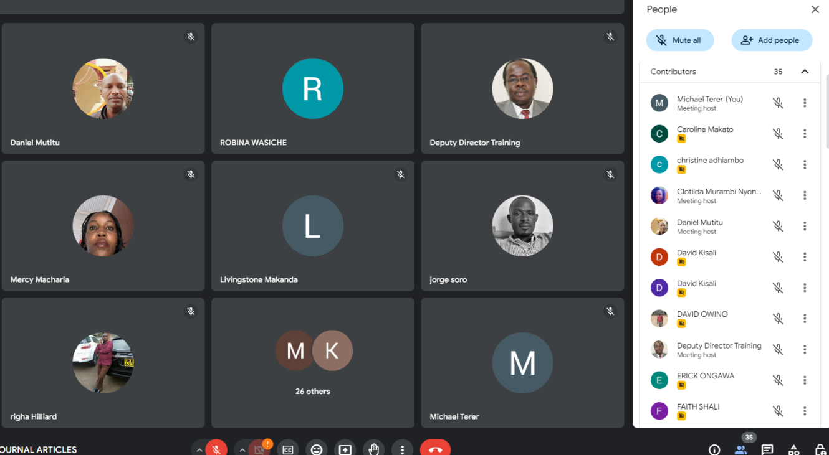

Figure 2

An excerpt of chats from a teacher’s online CoP platform
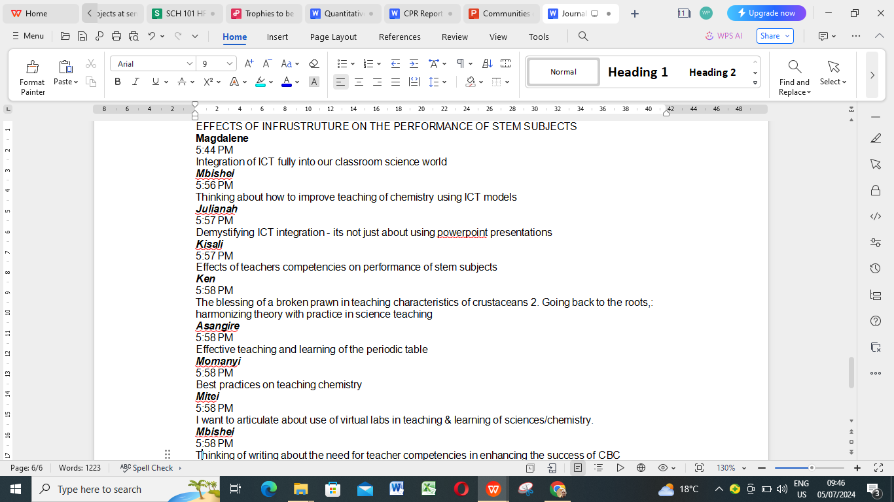

Conclusion
This study has shown that the majority of junior schools need to be equipped with adequate instructional, infrastructural, and technological resources. This could deny teachers and learners the opportunity to acquire relevant knowledge or skills and competencies, respectively, that could enable them to choose a desirable pathway according to their interests, abilities, and career choices as they proceed to senior school. The teachers also indicated that they needed to receive adequate professional support to enable them to handle the varied learning areas being taught at the junior school level. The majority of the teachers indicated that they are handling learning areas they had never learned in their schooling at any level. Based on the teachers' propositions, there is an urgent need to establish sustainable teacher support systems, such as communities of practice, to continuously enhance their preparedness in handling CBC at JS.

References
Chorfi, A., Hedjazi, D., Aouag, S., & Boubiche, D. (2022). Problem-based collaborative learning groupware to improve computer programming skills. Behaviour & Information Technology, 41, 139-158.
Kisirkoi, F., & Kamanga, A. N. (2018). Continuous teacher professional support for effective implementation of basic education curriculum framework. Elsevier.
KICD (2016). Report on needs assessment for school curriculum in Kenya. Nairobi. Kenya
Name: Dr. Karanja Mutitu
Affiliation: CEMASTEA
Email: dmutitu@cemastea.ac.ke
Practitioner Journal of Mathematics and Science Teachers, (PJMST)
Volume 3 Issue 1, pp …….

Effective Teaching of the Periodic Table

Odeke Asangire Tophista
Abstract | The periodic table refers to the orderly arrangement of chemical elements into (period) and columns (group). The periodic table is one of the most central topics in chemistry. The teaching and learning of the periodic table have been found to be arguably challenging to most teachers and learners. The topic covers a wide range of other topics such as properties of elements, trends in their reactivity, the mole, uses of various elements, organic chemistry, radioactivity and industrial chemistry. Each of these topics mentions an element in it and therefore its knowledge is very important. Traditionally, the learning of the periodic table has been dwelling on the learner’s ability to memorize rather than understanding concepts. This article provides a teaching model for better understanding of the periodic table through foundational periodicity. The article explore the use of technology through simulations and audiovisuals and the use of crossword puzzles in understanding of the alkali metals. This article also highlights shortcomings experienced during the teaching and learning of the periodic table and makes suggestions on how it can be effectively taught and the learners to be able to enjoy the process of learning and understanding the periodic table.  Keywords: Periodic table, alkali metal, simulation, puzzles

1.0 Introduction
During my daily teaching of chemistry, I was in Form Three class teaching about the relationship between the mole and relative atomic mass. I realized that a majority of the learners seemed not to understand the concept of relative atomic mass of elements yet it was taught in Form Two. I wondered whether the students still understood that the relative atomic mass is a periodic table concept. It made me reflect how important it is to consider more effective methods for teaching the periodic table.
Learners need to understand the atomic structure and periodicity. Once the learner understands the periodic table, it becomes easier for them to apply the knowledge to the other topics in Chemistry which are closely related to the periodic table (Johanne 2023). Understanding atomic structure enables students to comprehend why elements interact—or do not—with one another as well as why each element is located in a certain place on the periodic table.

2.0 Improving Teaching and Learning Periodic Table
This article focuses on two methods which were employed to improve on the learning and the teaching of the periodic table. These are, use of technology and Crossword puzzle. These methods make the learning of the periodic table interesting and the learners get exposed to technology and critical thinking.
2.1 Use of Technology
The use of technology in teaching and learning has increased rapidly in the recent years ranging from laptops, video, websites, online learning platforms, programs and applications. Covid-19 pandemic accelerated the trend of use technology since it led to temporary closure of schools and a shift to online teaching and learning.

With technology, learners collaborate to solve challenges in the periodic table. During the Covid-19 pandemic for example, online platform such as WhatsApp group played a key role in learning. Learners were given tasks on the concepts of the periodic table through their parents’ WhatsApp groups. The learners collaborated with their peers where they discussed on the work given to them. When the learners came back to school, there was greater improvement on the performance on the periodic table questions. When I asked the learners, what had changed, they confessed to having been discussing about the periodic table on their WhatsApp group. Learning according to the learners was also enjoyable.
The use of audio-visuals helped in improving the learning of the properties of the elements. When I was teaching the reactions of alkali metals, I downloaded videos from YouTube , showed it to the learners and then asked questions from the same. By observing the videos that showed the reaction between alkali metals with water, the learners were able to clearly differentiate the reaction rates of alkali metals. This gave them a better understanding than theoretical approach. The learners were also exposed to online access of content from the Khan Academy (https://www.khanacademy.org/). They watched videos and animations about the periodic table, and when questions were posed, they were able to respond appropriately.
The most interesting technology I used in teaching of the periodic table was the use of simulations. Physics Education Technology (PhET) interactive simulations, is a project that creates and hosts exportable explanations as stated by Rahmawati et al. (2023).
The PhET simulations incorporates research based practices on effective teaching of the periodic table as a topic in chemistry. The simulations are flexible and make learning enjoyable. I placed learners in groups and by use of intuitive game-like environment, where dynamic visual representation made the invisible visible. The lessons specific objectives were highlighted to the learners and were guided on what was expected of them. The learners were able to connect ideas from the theoretical periodic table to real world phenomenon. I noted that even the learner who usually appears not interested in learning chemistry had developed a positive attitude towards chemistry after getting exposure to PhET simulation. Figures 1, 2 and 3 shows Screenshots and pictures of learners studying the periodic table using the Khan Academy online materials.

Figure 1
Screenshot of the Khan Academy website
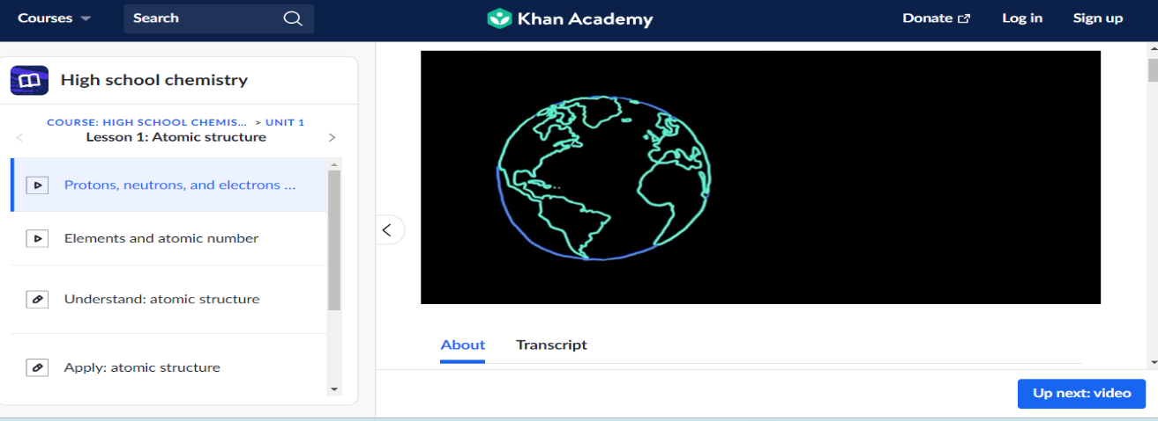

Figure 2
PhET Simulation of Neon atom
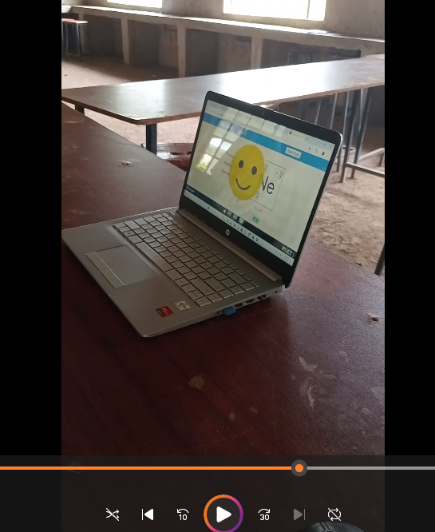
Figure 3
Photograph of learners manipulating the PhET simulations
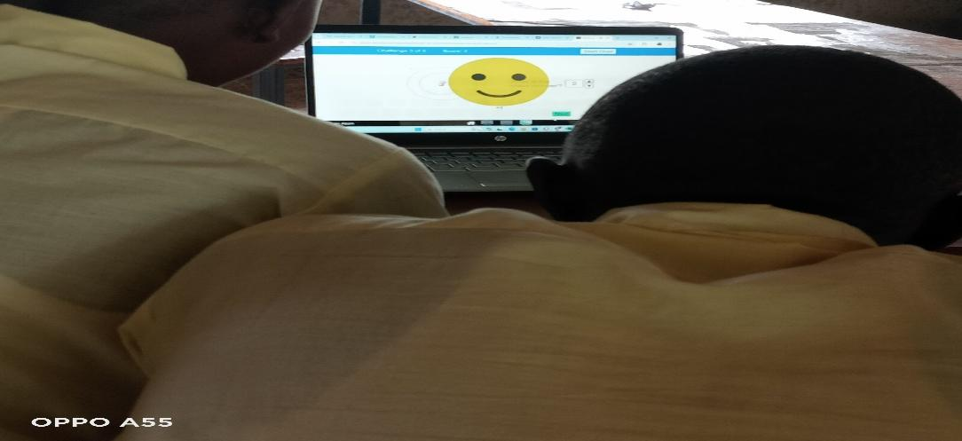

2.2 Use of Crossword Puzzle
This method involved the use of puzzles in answering questions related to the periodic table as elaborated by Lewi (2015). A puzzle on alkali metals was given out to the learners with missing elements. The learner then fills the blank spaces in the crossword puzzle with the correct name of the element in the blank spaces. The learner does the work individually or in a group. The puzzle not only forms basis for problem solving but also creates critical thinking. The use of crossword puzzle is easier and cheaper that requires a lot of concentration from the learner. Figure 4 illustrates a sample of the puzzle I used for teaching of the alkali metals.

Figure 4
Crossword puzzle on Alkali metals.
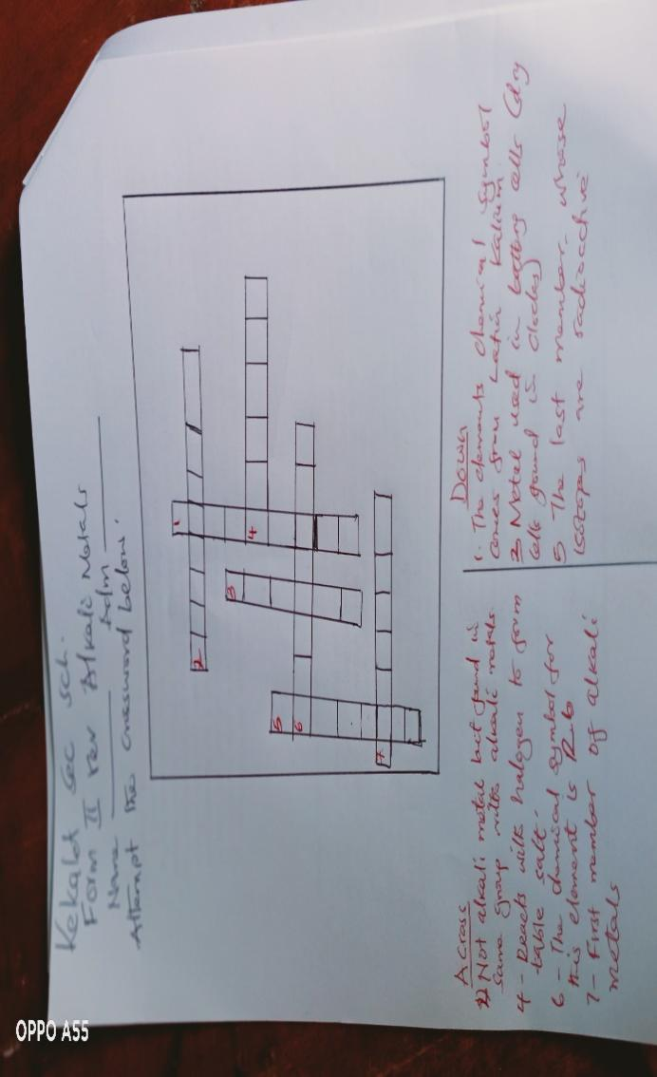
Conclusion
The teaching of the periodic table for a very long time has been dependent on use of theoretical lecture method. The use of technology and crossword puzzles in my teaching has paved way for more creativity and fun in learning by the learners. These methods add fun to learning and has tremendously improved the learners knowledge and understanding of the atomic structure. Despite the challenges of technological know-how by the learners such as: computer illiteracy, poor network and internet connectivity, the teachers’ improvisation skills can bring a greater positive impact on learning. These methods have enabled the learners to love learning since it creates fun in learning.

References
Imbert, C. and Sandler, P. J. (2020). Advances in Inorganic Chemistry, (2nd Edition), Elsevier.
Johanne, B. (2023). Education in Chemistry, (1st Edition), Chemistry Royal Society
Levi, P. and Rosenthal, R. (2015). The Periodic Table (2nd edition), ACS.
Muasilia, M. (2019). Chemistry Students Book Two, (6th Edition), KLB, Nairobi.
Rahmawati, Y., Hartanto, O., Falani, I., & Iriyadi, D. (2022). Students' Conceptual Understanding in Chemistry Learning Using PhET Interactive Simulations. Journal of Technology and Science Education, 12(2), 303-326.

Name: Odeke Asangire Tophista.
Affiliation: Kekalet Secondary school
Email: odeketop@gmail.com

Practitioner Journal of Mathematics and Science Teachers, (PJMST)
Volume 3 Issue 1, pp …….

Let the Learner Ask: Redefining Question-Answer Teaching Method to enhance Meaningful Learning

Kennedy Musyoka Kivonya
Abstract | The Question-Answer method is one of the commonly employed methods in any classroom. The method aims to enhance the level of interaction in the lesson and facilitate real learning. However, research has shown that questioning in school is usually done by the teacher, mostly asking questions that do not promote high-order thinking skills. It is envisaged that for active and meaningful learning, the learner should be stimulated to develop the ability to ask questions and gather information in answer to their questions. In such a scenario, the teacher will only scaffold the development of questions by the learner while supporting the process of information gathering to create knowledge. The efficacy of the learner questioning more instead of the teacher was demonstrated during remote learning lessons where a learner was given remedial teaching in Biology. During asynchronous meetings, the learner would be assigned work and then report at the start of the next synchronous meeting. In one session, the learner reported how they had made an astounding observation which made them ask questions, and how they became curious to look for information; than before; in answer to their questions. However, the learner hadn’t got all the answers but most importantly, the curiosity triggered her to learn better. A teacher needed to innovate ways to promote learning approaches that stimulated learners to ask questions in the process, hence meaningful learning.  Keywords: Auto–answering, Auto–questioning, Meaningful learning, Scientific approach, Self–controlled learning.

1.0 Introduction
Question-answer method (or Socratic maieutics) is a teaching strategy involving dialogue between individuals, asking and answering questions to stimulate critical thinking and draw out ideas and underlying assumptions (Delić & Bećirović, 2016). According to Dalim et al. (2022), this method helps learners collect their thoughts according to their understanding. The method has been approved as a great contributor to critical thinking since it applies continuous questioning of thoughts, methods, and judgment together with internalization and operative listening. The method is also an active communication as it involves discussion among students, as well as interaction between students and teachers. Activities that promote asking questions encourage students to think critically about the concept studied (Butler et al, 2023). It helps them direct their learning as they try to merge their prior knowledge and new information to make sense of these ideas. Questioning is key to problem-solving, and it guides teachers in their work (Almeida, 2012).

Socratic method however has some gaps, according to Almeida (2012), while employing this approach, teachers dominates the classroom questioning and asking between 300–400 questions a day, accounting for up to 50% of class time. Each student asks, on average, one question per week. The teacher’s questions are rarely answered and students are seldom stimulated to ask and usually show low questioning ability (Rahman, 2021). The low ability is due to the lack of scaffolding of teachers in learning (Wakhidah &Laelasari, 2022). This necessitates switching to a productive approach that develops students' capacity for questioning and answering.

2.0 A Shift in Questioning From Less by a Teacher to More by the Learner
To improve students' ability to ask and respond to questions, the idea of a scientific approach to meaningful learning could be used. Meaningful learning refers to the act of higher-order thinking and development through intellectual engagement that uses pattern recognition and concept association. It may include critical and creative thinking, inquiry, problem-solving, critical discourse, and metacognitive skills and occurs if students are given freedom and confidence, they can find their answers and develop their knowledge, both in the classroom and in practical life (Vargas-Hernández (2022).

Meaningful learning in any area requires a scientific approach. Learning using a scientific approach requires students to find concepts through the steps of observing and asking questions. The result of learning uses a scientific approach in the form of knowledge or concepts found by students through the process of observing-asking-gathering-information-reasoning-communicating. It is therefore pertinent for a teacher to come up with approaches for providing scaffolding for students so that students can observe and ask questions properly (Wakhidah&Laelasari, 2022). This is a departure from the traditional approach where the Socratic method involves a shared dialogue between teacher and students. The teacher leads by posing thought-provoking questions. The learner answers and is also expected to ask questions that the teacher answers. Thus the discussion goes back and forth. Unfortunately, the questioning is usually from the teacher’s side one-sided.

The best approach to use questioning in learning is where the learner is stimulated to ask questions and gather information to answer them. This entails a situation where children persist in their questioning to obtain information, rather than just to get attention or for their own enjoyment (Butler et al, 2020). This strategy is based on two principles; first, the theory of unfoldment that all knowledge is within the child, the teacher cannot teach anything from outside. Second, knowledge can be emitted by linking the questions with one’s answers.

3.0 Real Experiences
I was prompted to propose a change in questioning from teacher to learner as a result of multiple situations I encountered during my teaching career. In this article, I will share two of these scenarios. In the first example, I was providing remedial instruction via remote learning to a learner during the COVID-19 pandemic. The second one is about an experience I had in one of my Biology classes.
In the first case, I was contracted to give a learner remedial lessons in Biology. This learner was starting to get dejected as a result of a low grade in her first Biology examination in secondary school. The learner had reported to Form One with a hope of pursuing a career in the field of medicine, where an excellent performance in Biology is mandatory. In her end-of-term one Biology examination she scored 23%. That wasn’t a good start for a scholar with a career goal like hers, so it was really depressing. A remedial measure was necessary and the most feasible during COVID-10 pandemic was via remote learning. I did some background checks and realized that two key things worked against the girl: her attitude towards science and more so Biology, and probably the instructional approach she was exposed to in school. I did remedial coaching during two consecutive school vacations and this moved the learner from 23% (Grade E) to a B- at the end of Form 1 and a B+ in her Kenya Certificate of Secondary Education (KCSE) Biology Examination.
To attain such success, I used the scientific approach to meaningful learning to help change her attitude towards the subject. I leveraged on self–controlled learning through auto–questioning, auto–answering, which worked very well. Auto–questioning, auto–answering is a skill that needs to be cultivated in the learner through innovative thought-provoking class activities. These are activities that provoke a lot of curiosity in the learners, driving them to set out to look for information to satisfy their curiosity. In one of the sessions, I assigned the learner an activity to investigate osmosis as shown in Figure 5.

Every synchronous session began with the learner giving a report of the work that had been assigned previously. During the synchronous meeting that followed the activity in Figure 1 above the learner reported the following: “I observed that the groove in the potato was full of water and the salt was no longer there. That was so interesting and I asked myself, 'How now?’! ‘Why? ‘What has happened? It was evident from her tone of questioning that what she had observed had really aroused a lot of curiosity in the learner and that had actually made her look for answers to those own questions. Her readiness to study had increased as a result and my initial objective was being attained. The learner was starting to learn better by questioning her experiences and navigating her way out. She was finally developing the scientific mind that I had aimed to develop in her. This was also a turning point for her learning. The learner had discovered that science was fun and it made the learner look forward to exploratory activities which would stimulate her to ask her own questions and then go ahead to seek answers to her questions all by herself. That gave the learner an opportunity to be in control of her learning and promoted active real learning in her. At the conclusion of the remedial program, the learner was confident that she was confident to do Biology. I had also the same confidence since she had evidently developed reins on her learning, by simply learning to ask questions in the learning process and working out answers to her questions.
That experience led to the concurrence with the fact that questioning is the key to all educative activity above the habit-skill level, in which strategy is focused on achieving cognitive objectives and bringing knowledge to the conscious level. However, it requires a reverse such that the burden of asking is shifted to the learner. Since then, I have deliberately been developing classroom learning activities or creating situations that would provoke the learner to ask questions, out of curiosity to learn. This approach has made teaching easy and effective and learning real.

Figure 5: Screenshot of one of the activities assigned to the learner in the Google Classroom 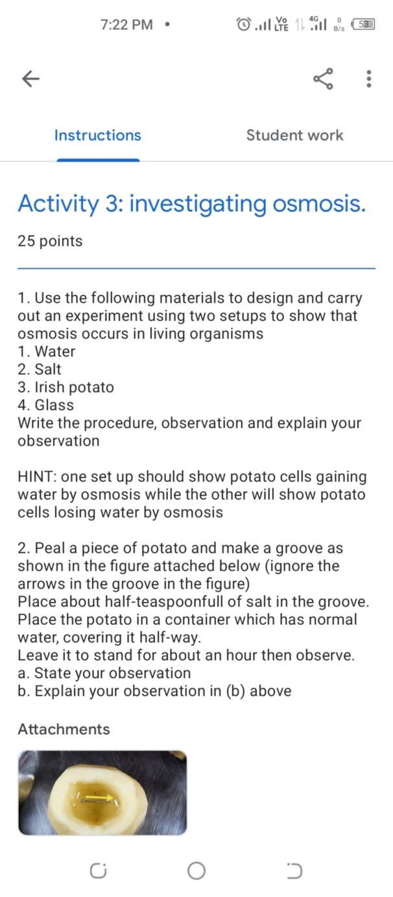

The second experience was about a Biology lesson in which I was teaching about the kidney. A learner asked me how heavy the human kidney was. I recalled the auto-question, auto-answer method of instruction and instructed the students to conduct their own research, find the information, and then report back the next class. They were reluctant to comply at first, but they agreed to comply after I emphasized the benefits of doing research on their own to find answers with questions.
The following day each brought with them to class answers with the question and also their own questions. In giving the answer to the initial question; one of them further reported; “I did further research and found that the kidney is also called kidney nephron”. Well, that information was not correct but it wasn't far from the point, and even though it was wrong, it provided a good introductory point to what we were learning that day: the structure and function of the kidney nephron. It was an opportunity for easy teaching and effective learning. Questioning can have a dramatic impact on learning. A good question in class can provoke curiosity, stimulate thought, and trigger a discussion or serve as the basis of an activity that leads to new or deeper understanding; the results are greater when the learner asks (Felder & Brent 2024).

Conclusion
Learning experiences where learners are provoked to ask questions in the learning process are rarely provided in actual classroom practice. Consequently, learners are not provoked to ask questions in the learning process and teacher thus ends up dominating the classroom discourse. This article provided information on how meaningful learning in the classroom can be promoted by using the Socratic/Question-Answer method-auto–question, auto–answer approach. Information on how, using this method where learners were stimulated to ask questions out of curiosity that provoked them to search for the answers, rather than just the teacher asking questions all the time were presented. In the two scenarios presented, learners were motivated to learn as they were in control of their learning. In particular the learner involved in the remedial program registered an improvement in her performance. Even though this only involved one student, it shows that increased learner performance can arise from a change in questioning practices from the teacher to a learner-centered, auto-question, auto-answer strategy.

References
Almeida, P. A. (2012). Can I ask a question? The importance of classroom questioning. Procedia-Social and Behavioral Sciences, 31, 634-638.
Butler, L. P., Ronfard, S., & Corriveau, K. H. (Eds.). (2020). The questioning child: Insights from psychology and education. Cambridge University Press.
Dalim, S. F., Ishak, A. S., & Hamzah, L. M. (2022). Promoting Students’ Critical Thinking Through Socratic Method: The Views and Challenges. Asian Journal of University Education, 18(4), 1034-1047
Delić, H., & Bećirović, S. (2016). Socratic method as an approach to teaching. European Researcher. Series A, (10), 511-517
Felder, R. M., & Brent, R. (2024). Teaching and learning STEM: A practical guide. John Wiley & Sons.
Rahman, A. A. (2021). Improving Students’ Questioning Skills Level through Inquiry Training Learning Using Digital Learning Tools. Report of Biological Education, 2(1), 19–27. https://doi.org/10.37150/rebion.v2i1.1178
Vargas-Hernández, J. G., & Vargas-González, O. C. (2022). Strategies for meaningful learning in higher education. JISTECH: Journal of Information Science and Technology, 2(1), 47-64
Wakhidah N., Laelasari, I. (2022) Observing Skills And Questioning Skills: Are They Correlated In The Learning Process? Thabiea: Journal of Natural Science Teaching, 5(2), 131-144.
Wilberding, E. (2021). Socratic Methods in the Classroom: Encouraging Critical Thinking and Problem Solving Through Dialogue (Grades 8-12). Routledge.

Name: Kennedy Musyoka Kivonya
Nguutani Secondary School
P.O. BOX 338 – 90400; MWINGI. KENYA
TEL: +254 721 403 361
Email: kivsmania@gmail.com

Practitioner Journal of Mathematics and Science Teachers, (PJMST)
Volume 3 Issue 1, pp …….

From Resistance to Routine; Embracing Lesson Planning in my Teaching

Naima Adan
Abstract | Lesson planning is one of the most significant yet tedious things to do as a teacher. This article documents my journey, “From Resistance to Routine,” in embracing lesson planning in my teaching. Initially, I viewed lesson planning as burdensome and time-consuming, and I preferred spontaneous teaching methods. My teaching heavily relied on the course book and accompanying teacher’s guide. Through critical self-reflection, I analysed my teaching methods and identified areas where well-structured planning could bring about positive change. I realized that a lesson plan facilitates a smooth transition between various lesson components, fostering a coherent and engaging learning experience for students. By preparing a lesson plan, I would always look for new resources, integrate technology, and come up with something new. The benefits of embracing lesson planning in my teaching became evident. My lessons have become well organized, and all the instructional materials are available. There is increased engagement and participation from the learners. It has also enabled me to address individual learning needs among learners. The Journey underscores the importance of reflective practice in professional development and the continuous pursuit of teaching excellence.  Keywords: Lesson Planning, Engagement, Effective Teaching, Professional development, Reflective practice.

1.0 Introduction
In the first few years of my teaching career, I often found myself resisting the idea of writing a lesson plan. I preferred to teach lessons with spontaneity. I used to write lesson plans only when the Teachers Service Commission (TSC) officers conducted supervisory visits or when the administration conducted lesson observations hence requiring them to be uploaded on the Teacher Performance Appraisal and Development (TPAD) platform for evaluation and accountability purposes. My lesson plans were primarily for administrative purposes rather than for my use.
During the few times I have prepared lesson plans, I have noticed a marked difference in the organization and effectiveness of my lessons compared to when I did not. I, therefore, started prioritizing and consistently preparing detailed lesson plans to ensure my lessons were impactful.
Initial resistance
Lesson planning is of central importance to the teaching of all subjects in school (König et al., 2021). The hardest part of my teaching career was lesson planning. It felt like a hassle. I was not alone in this. Many of my colleagues shared a similar disdain for lesson planning. It is not just the writing of the plan that is laborious; it is the intellectual contemplation that goes into it. I must figure out ways to make my instruction clear and engaging. I must differentiate the content, pedagogy, and assessments based on the learner’s needs.

Figure 1: Teacher reaction to supervisor’s visit.
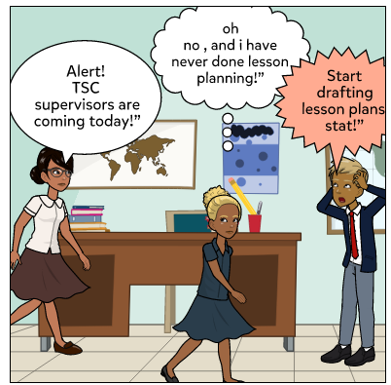
I saw it as something I had to do to avoid scrutiny from the TSC supervisors.
With the number of lessons to prepare, overseeing sports activities, and constantly assessing learners’ work, lesson planning added to my workload. I used to question the need for a lesson plan when spontaneity seemed sufficient as long as the students understood the concept. My focus was on compliance, not on enhancing the quality of my teaching.

2.0 The turning point
The turning point occured when I reluctantly started making lessons for supervisory purposes. During these times, I noticed a remarkable difference in how smoothly the lessons flowed and improved learner engagement. Activities seemed to connect more logically and learners showed a deeper understanding of the concepts taught. It was then that I started reflecting on my teaching practice and realized my reliance on the course books was not enough. Lesson planning was more than a box to tick for administration. It was a tool that could make my lessons run more smoothly and effectively. The importance and necessity of a lesson plan is similar to a building plan. Just as a construction engineer designs a plan before building, the teacher should also design an educational plan in which the content of education, teaching method, media and educational aids are predicted and teach according to this plan (Farhang et al., 2023).

3.0 Embracing Lesson Planning
Determined to make lesson planning a regular part of my routine, I started small. I set aside a specific time each week to outline my objectives, activities, and assessment methods for the upcoming lessons. At first, the process was tedious and time-consuming, but over time, I found a rhythm and structure that made planning quicker and more manageable.

3.1 Steps to Effective Lesson Planning
A lesson plan is a systematic and detailed outline developed by educators to structure an instructional period. It serves as an essential roadmap for a teacher, ensuring that a lesson's objectives, contents, activities, and assessments align with the desired learning goals.
Using a lesson plan in the classroom is pivotal for several reasons. It guarantees the educator a well-defined sequence to follow, facilitating a smooth transition between various lesson components. This fosters a coherent and engaging learning experience for students. A lesson plan allows a teacher to align the instruction with students' specific needs, abilities, and interests, thereby promoting differentiated learning. It enables a teacher to assess the effectiveness of the lesson through predetermined success criteria, aiding in the continuous improvement of teaching practices.
Specifying concrete objectives for student learning will help you determine the kinds of teaching and learning activities you will use in class, while those activities will define how you will check whether the learning objectives have been accomplished (Milkova, 2020). To make my lesson planning more efficient, I followed the steps illustrated in Figure 2.

Figure 2: Steps to Lesson Planning
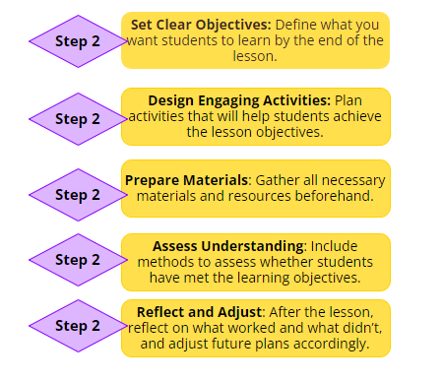
The benefits were immediate and significant. I could anticipate potential challenges and come up with strategies to handle them. Lesson planning gave me a sense of control and readiness, reducing the stress and anxiety of improvising in the classroom. It allowed me to track student progress more effectively and make informed decisions to support their development. Reflecting on each lesson and adjusting my approach based on feedback became a key part of my professional growth.
3.2 Impact of Lesson Planning on Student Performance
After adopting lesson planning, I have observed significant improvements in learners’ performance, particularly in assessments. My learners have achieved higher average scores compared to previous times. The following table presents a comparison of average mathematics assessment scores before and after implementation of lesson planning for a sample of learners
Table 1
Learners’ Performance analysis
Learner | Pre-Implementation performance | Post-Implementation Performance | Improvement
Learner A | 65% | 87% | +22%
Learner B | 57% | 76% | +19%
Learner C | 36% | 55% | +19%
Learner D | 23% | 54% | +31%
Learner E | 17% | 35% | +18%

Additionally, the class mean in Mathematics has improved significantly. The following table presents a comparison of Mean Scores of Form Three Mathematics assessment before and after implementation of lesson planning.

Table 2
Class performance analysis
Metric | Pre-Implementation performance | Post-Implementation Performance | Improvement
Mean Score | 3.5626 | 5.8351 | +2.2725

3.1 The Broader Perspective
Despite my transformation, I recognized that many teachers still struggled with the same resistance to lesson planning that I once did. Many teachers, overwhelmed by their daily responsibilities, found it difficult to prioritize this important task. While the demands on teachers are substantial, the benefits of lesson planning make it an indispensable practice.

3.2 Importance of Lesson Planning
Effective lesson planning contributes to successful learning outcomes for students in several ways. A well-designed lesson plan:

Helps students and teachers understand the goals of an instructional module
Allows the teacher to translate the curriculum into learning activities
Aligns the instructional materials with the assessment
Aligns the assessment with the learning goal
Helps assure that the needed instructional materials are available
Enables the teacher to address individual learning needs among learners.

Effective lesson planning can also contribute to the teacher’s own success and well-being. Teachers teach because they want to support students, and effective lesson planning can contribute to job satisfaction when a lesson is successful or a student does well on an assessment. Having a skilfully-planned lesson can also make the act of teaching more pleasurable by increasing the teacher’s confidence in themselves and letting them focus more on interaction with the students than on what is supposed to happen next. Importantly, good planning can save time by avoiding last-minute efforts to buy supplies or create materials needed for a day in the classroom. Teachers can use that reclaimed time for themselves or other parts of their lives, increasing work-life balance.

Based on my experience, I strongly support a cultural shift in schools to recognize and support the crucial role of lesson planning in effective teaching. By making this practice a priority, we can manage the complexities of our profession and provide more organized, engaging, and effective lessons.

Conclusion
Looking back at my journey from resisting lesson planning to make it a routine, I can see how much it has changed my teaching for the better. Initially, lesson planning seemed like too much task, and only did it to meet the supervisor’s requirements. However, once I started writing down my lesson plans, I noticed a huge difference in my classes. It improved the learning environment. Reflecting on each lesson and making adjustments became a crucial part of my growth as a teacher.
I encourage fellow teachers to embrace lesson planning as a regular part of their routine. Start small, maybe with just one lesson at a time, and gradually build up. Collaborate with colleagues, be flexible, and prepare for adjustments. With time, you will find that lesson planning not only makes teaching easier but also enhances your learner’s experience.
Lesson planning is more than just an administrative requirement. It is a tool that can transform teaching and learning. By making it a regular practice, teachers can provide learners with the quality education they deserve, and in turn, find greater satisfaction and effectiveness in their teaching.

References

Farhang, Asst & Hashemi, Asst & Ghorianfar, Sakhi Murad. (2023). Lesson Plan and Its Importance in Teaching Process. International Journal of Current Science Research and Review. 06. 10.47191/ijcsrr/V6-i8-57.
König, J., Krepf, M., Bremerich-Vos, A., & Buchholtz, C. (2021). Meeting cognitive demands of lesson planning: Introducing the CODE-PLAN model to describe and analyze teachers’ planning competence. The Teacher Educator, 56(4), 466–487.
Milkova, S. (2020). Strategies for Effective Lesson Planning. Center for Research on Learning and Teaching.

Name : Naima Adan
Moi Girls School Marsabit Secondary School
Email: naimaadan254@gmail.com

Practitioner Journal of Mathematics and Science Teachers, (PJMST)
Volume 3 Issue 1, pp …….

Learner involvement in preparing Resources for ICT Integrated Biology Lessons

Julianah Vore Mwanjelle
Abstract | ICT integration in teaching and learning forms the centre most pillars in achieving STEM oriented future as envisioned in Standard Development goals of our country. However, ICT has not been well embraced as it ought to, due to failure of the government to fund sufficient ICT infrastructure in schools. Most affected schools are those that are found in Rural Kenya. Millennial tutors have a chance to make ICT integration in teaching and learning work using innovative ways of bridging the challenges faced in the implementation. This will be made possible if learners are put at the centre stage in creating resources for study and ICT integration. It’s against this background that this article shares the experiences I’ve had as a millennial teacher in a sub-county rural school in Kwale County. I discuss the importance of innovation and involvement of students in creating ICT resources for use in teaching and learning. This approach has had a great impact in my teaching career as I’ve seen more students select Biology as a subject of choice in the school, there is increased curiosity and interest in learners who continuously provide the learning resources for study and a great improvement in the subject mean scores over the last two years  Keywords: ICT integration, Leaner involvement, ICT resources, millennial tutors, Communities of Practice (CoPs)

1.0 Introduction
Learners in sub-county rural schools face many challenges in conceptualizing content while learning Biology. Limited exposure to technology and a need for teaching and learning resources in these schools contributed to those challenges. Most rural schools need more basic ICT infrastructure, including computers, internet, digital cameras, smartphones, etc. Power outages are also common, with the schools going for months without power, mainly during the rainy season. Lisa (2017) observed that the teaching and learning process involving the use of technology continues to hold students back as passive observers.
ICT integration requires enough infrastructures to be adequate. The lack of infrastructure calls for innovative ways of enhancing teaching and learning with the few resources available. Creative teaching and learning practices provide students with learning experiences that promote 21st-century skills characterized by knowledge-building, problem-solving, skilled communication, collaboration, self-regulation, and using ICT for teach (Shear et al., 2009). Despite the limited resources in rural sub-county schools, teachers must consider Integrating ICT into the teaching and learning process. Involving learners in creating the learning resources excites them, brings out curiosity, and makes learning more enjoyable.
2.0 Millennial Instructors: ICT Paradox!
Millennial teachers form the highest percentage of teachers in our current secondary schools in Kenya. The teachers exhibit the following characteristics : Autonomous: They are self-governed, detached, and independent. Millennials are less likely to be affiliated with traditional institutions such as teacher-centered lessons, textbooks, and lectures. They are also more likely to be less engaged in the workplace and more unconstrained. Millennials don't flow with funny old perspectives, like "That's how it has always been done." Instead, they advocate for school changes and the teaching career. Optimistic: they always want to be associated with or do what makes them feel important. They are quick to change jobs and employers whenever they feel discontented. Connected: They embrace CoPS so much that they remain informed and networked. Information access is easy for them because of the many forms of social networks.Energetic: These are young people at their prime age who are full of energy to work and transform their lives through their careers. However, they quickly get demoralized by managers who fail to understand their needs, and whenever they can't quit, they become very rebellious. They can also sabotage, then sit back and watch as institutions collapse.
These individuals, who form the most significant percentage of tutors, are supposed to be the backbone of ICT integration in learning institutions. However, that's not the case. Instead, they are the most demotivated staff, always lamenting and unpredictable due to the following; Generationa gaps, whereby their managers are typical Gen X individuals who only believe in traditional methods of doing things, a colonial mindset. Lack of resources, ICT integration requires heavy facilitation to acquire the necessary resources to make it a reality. Kenyan rural schools need more resources, better infrastructure, and better internet connectivity, making millennial tutors feel demotivated and out of place.
3.0 ICT Integration; A Piped dream?
Here is the dilemma. Gen X managers will not see the need to provide ICT resources for teaching and learning because 'It has always worked without such' mentality. Millennial tutors who 'MUST' be provided with the resources to be productive: digital mentality and Gen Z learners whose curiosity is way above average, thirsty for information and more straightforward ways of doing things, and hands-on mentality.

3.1 Biology lesson: how it relates
Biology is a subject that requires a lot of innovation, a curiosity-oriented mind, and research for meaningful learning to take place. Where resources are scarce, and a lack of willpower exists, the millennial teacher then needs to come in handy to develop a solution through an innovative mind. Traditional teaching methods where the teacher is the center of all knowledge will not work in such a way. Still, new pedagogies that are mostly learner-centered will be most appropriate for creating solutions to this problem.
3.2 Creating own ICT resources using simple infrastructure e.g. Smart phone or Simple digital camera.
Ask learners to collect as many photographs and videos as possible of every living organism they come across in every place they visit and around their homes during school holidays, in their natural habitats. The learners then share the photographs with the teacher in the class or the subject WhatsApp group, creating a photo bank with raw data.The teacher then sorts out the photographs and videos, edits them, and organizes them to suit different learning areas, creating a library for reference. The teacher can also print them to obtain hard copies. This digital library is safely stored, and teachers and learners can share it with colleagues through Communities of Practice.
If properly used, these platforms can be rich resources for teaching and learning. Students in semi-arid regions, for instance, can take photos of as many xerophytes as they can find and share them with their teachers, who in turn share them with colleagues in non-arid areas. Similarly, students who reside in coastal areas can collect photographs of halophytes only found in those regions and share them with their teachers, who share them in their communities of practice. The process creates a rich library of living things.

Figure 1: Acacia spp. Teachers could use these resources to create virtual lessons and upload them to learning websites for review and assessment for future reference. Teachers can use these resources to teach topics like classification and ecology in biology, reducing the costs incurred in ecological tours. This student involvement in taking the photographs builds their curiosity, makes them feel part of the learning process, and improves their understanding of biology concepts. It also makes learning more enjoyable.

This approach has made Biology the favorite subject of most students in my school, with very high enrollments despite it being an optional subject. The subject mean- core has also shot up suddenly after trying out this approach.

Figure 2: Random Xerophyte The other way of doing it, especially in biology practical where resources are few is by letting another teacher with resources carry out the practical, say food test with their learners in school and record the whole lesson, from preparation, teaching, demonstration and conclusion. They then share the lesson in CoPs where another teacher without resources can project the same lesson to their learners. The teachers should preview the lesson in advance and come up with some questions to pause in order to enhance learner engagement.

Table1
Biology entry and K.C.S.E mean-score of Mangawani Secondary School over 3 years
Year | Entry vs. Total No. Of Candidates | Mean score
2021 | 27 out of 53 | 1.91
2022 | 52 out of 54 | 3.33
2023 | 44 out of 44 | 6.15

Conclusion
Teachers and learners can do it! It is possible to integrate ICT in teaching and learning biology even with few resources by involving the learners in creating such resources. ICT integration is one way of making learning more learner-centered and attractive. Through WhatsApp platforms, teachers and learners can form communities of practice through which teachers can share learning resources. This approach enhances a resource bank for teaching biology. Additionally, it is possible to bridge learning gaps in rural and urban areas through the formation of communities of practice. Let's make it happen, fellow millennial!

References

Bakia, M., Shear, L., Toyama, Y., & Lasseter, A. (2012). Understanding the Implications of Online Learning for Educational Productivity. Office of Educational Technology, US Department of Education. Retrieved from https://shorturl.at/TlLA5
Capalad, J., Halili, C. & Vargas, D. (2023).Teaching as a Career: From the Point of View of Millennial Teachers Retrieved from https://ssrn.com/abstract=4638167 or http://dx.doi.org/10.2139/ssrn.4638167
Chorfi, A., Hedjazi, D., Aouag, S., & Boubiche, D. (2022). Problem-based collaborative learning groupware to improve computer programming skills. Behaviour & Information Technology, 41, 139-158.
Finnegan, L. A. (2018). The impact of technology on the teaching and learning process. In Handbook of research on human development in the digital age (pp. 235-257). IGI Global.
Hodges, T. (2016). Managing millennial teachers: Major challenge for schools. Gallup Business Journal, 1.

Name: Julianah Vore Mwanjelle
Affiliation: Mangawani secondary school, Kwale County
Email: julianahmwanjelle@gmail.com

Practitioner Journal of Mathematics and Science Teachers, (PJM&ST)
Volume 3, Issue, 1,pp…..

“Adventure with Nitty Gritty” Volte facing experience for 21st Century Learners.

Hilliard Peter Kiwaza Righa
Abstract | The 21st-century learner is privileged to be born in an era where the technology revolution is accurate, and humans are using computer technologies to perform tasks that would otherwise be mind-boggling. Unfortunately, the same technology may spark a negative connotation among technology users. More often, the current generation of learners rarely takes time to sink into the nitty gritty of subject matter, especially while studying mathematics and science subjects. Learning these subjects requires a higher order of mental processes, such as collecting, analyzing, synthesizing information, and building new knowledge to solve problems. Because learners know there are technology platforms used to handle a task, they do not bother themselves in making efforts to dig deep and understand concepts in science and mathematics. Their poor performance in STEM areas is primarily due to this. When students learn to approach concepts profoundly and understand things from the basic principles, their perspectives of the subjects may be dramatically transformed, and as a result, their performance can be enhanced.  Keywords: Nitty Gritty delves into more profound, passive processes, stimulus variation

1.0 Introduction
Technology has come to make work easier. Challenging tasks can be performed within the shortest time possible, saving a lot of time and resources that could have been used if it were not for technology. Online resources and software, which are fast, provide means by which humans acquire and utilize information at the mere touch of a button.
On the contrary, in equal measure, technology has also made people relax in the sense that the 21st-century learner has embraced it with a different connotation. The perception that any information can be sourced from the internet has made the learners relax. Most learners are interested in the end product rather than focusing on the process used to achieve it. In mathematics, learners are interested in getting the answer rather than the method used to arrive at the answer.

2.0 Critical incidence
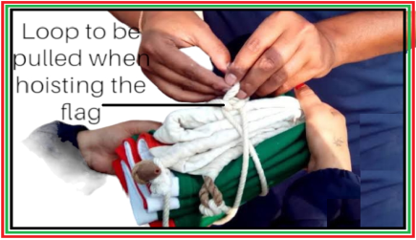
I have been watching this happen in our school every Monday and Friday during the flag-hoisting parade. For a long time, I noticed these scout students were not able to hoist the flag by just pulling the loop tied to the flag. It was just an easy skill to tie a loop that can easily be unloosened by pulling out a string. Later, I demonstrated to the scout leaders how to make a loop. I had assumed that the demonstration was adequately helpful, and my hope was that in the future, they would exercise this correctly. To my disappointment, in the successive parades, I realized that sometimes they would do it correctly, but many other times they would miss it out. This made me reflect deeply on why the scouts would fail to grasp such an easy skill despite my demonstration.
2.1 Getting into the details of a subject matter
I set out to investigate the gap that was making learners need help to grasp a concept that seemed simple. In a form-two biology lesson, we learned about the adaptations of the heart to its functions. I chose two classes, A and B, and designed different activities to cover the same subject matter. Later on, a continuous assessment test was administered to the learners, and the results were analyzed to ascertain how the questions on adaptations of the heart were performed.
2.1.1 Class A
We studied the structure of the heart as drawn in the textbook and were also given the opportunity to see the heart structure using online pictures. The learners were exposed to guiding questions on heart adaptation, which they were expected to discuss.
2.1.2 Class B
The learners studied the structure of the heart as drawn in the textbook; then, they were provided access to the internet to observe the same structure in three dimensions and discuss it using some guiding questions. I also gave them a chance to prepare models of the internal and external structures of the heart in their groups by making use of locally available materials such as rubber, paper, plasticine, straws, carton boxes, and polystyrene. Creativity and imagination were applied when making these models, and one could see the concepts of the adaptations applied. Their performance was favorable, as shown in Figure 2.
2.2 Procedure and Guiding Questions
You are provided with the following materials. Use them to construct a simple model of the external and internal structure of the mammalian heart.
- Waste paper
- Plasticine (assorted colors)
- Polystyrene
- Bookbinding glue
- Scalpel
- Plastic bottles
- Old rubber slippers
2.3 Activity guiding questions;
- What prevents the mixing of oxygenated blood and de-oxygenated blood?
- How is blood pumped to the rest of the body parts, some of which are very far away from the heart?
- What keeps blood in the ventricles from flowing back into the auricles when ventricles contract?
- What keeps blood that has just been pumped away from the ventricles from flowing back into the ventricles?
- Could the pumping action of the heart be generating some friction?
- How is the heart kept away from shock?
Figure 3: Structure of the Heart

2.3.1 Learners test achievement
After the test was administered to the learners, the following results were realized on the specific question discussing the adaptation of the heart to its functions, as shown in Table 1.

Table 1
Learners performance
CLASS | Roll | Scored above 7/10 | Scored 5/10 | Scored 2/10 | Scored 0/10
A | 44 | 3 | 11 | 22 | 8
Percentage |  | 6.8% | 25% | 50% | 18%
B | 43 | 33 | 6 | 3 | 1
Percentage |  | 76.7% | 13.95% | 6.97% | 2.32%

Figure 3
Sample group performance on Question 10

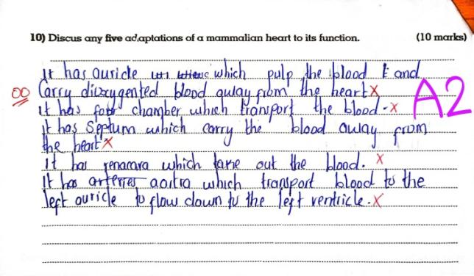


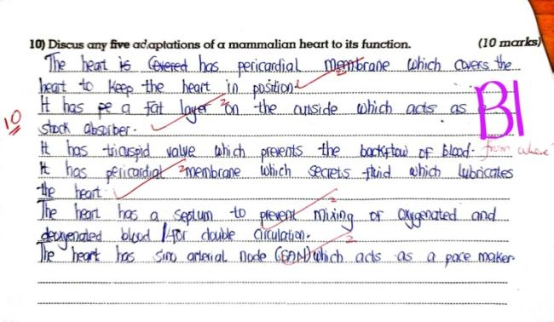


2.3.2 Remedial intervention for class A
From Figure 3, images A1 and A2 show class A learners' performance after being exposed to the questions on heart adaptation using the usual traditional method. Both groups scored zero marks. The identical learners were given an opportunity to experience similar activities done by class B. Using the same guiding questions and materials, I let them construct the internal and external structures of the mammalian heart. Amazingly, they exhibited imagination and creativity, just like class B learners. The identical learners were exposed to similar questions on the adaptation of the heart, and this time; I noticed the majority of them scored well in the question, as tabulated in Table 2.
Table 2: Class A learner's performance.
CLASS | Roll | Scored above 7/10 | Scored 5/10 | Scored 2/10 | Scored 0/10
A | 44 | 37 | 2 | 4 | 1
Percentage |  | 84% | 4.5% | 9.0% | 2.3%
From these results, it is evident that class A learners could have performed better in the heart adaptation questions than class B during the first experience. This is primarily attributed to the manner in which the subject matter was handled during the lesson. It is evident that learners in class B were exposed to an in-depth discussion of heart adaptation and delved deeper into the subject matter. Their class activities were also varied, ranging from class discussion and use of ICT to project-based learning, where they employed their creativity to bring out the adaptations of the heart in making the heart models. An adaptation of a structure shows the structure in question and how it is modified in relation to its work.
Saunders andHolden (2016) observed that gamification in learning is more dramatically and effectively evident when shared curiosity and improvisation emerge among learners. Gamified learning is something that requires more than individual play in a shared setting. In this case, learners had to put their heads collaboratively and apply creativity to come up with the models.
Bray et al. (2023) found that learners need to be exposed to the pedagogical activities of the 21st century to have the opportunity to develop relevant skills and abilities. Since it's widely accepted that teachers often use a variety of pedagogies in and out of the classroom, such pedagogies give learners a close-up look at the concept being studied. This enhances learning by encouraging the accomplishment of intended learning outcomes, leading to the development of desirable competencies.
The moment the learners in Class A were subjected to a similar experience as Class B, they exhibited a better performance. This demonstrated the power of giving an in-depth approach to a subject matter during learning coupled with a variation of learning experiences, which vary the stimulus. My results support Schabas's (2023) suggestion that game-based learning be used in science classes as a valuable way to give students a variety of stimuli. He pointed out that guaranteeing students' active participation in the learning process enhances the learning environment, a strategy that has the ability to promote an interactive learning environment. Enhancing learning efficacy leads to improved retention of learned concepts.

Conclusion
This study has emphasized the need for learners to delve deeper into a subject matter in order to enhance their understanding of scientific concepts. It is important to note that there is a close relationship between the methods of instruction used by the teachers and the extent to which learners acquire the desired knowledge, skills, and competencies. If teachers employ methods of teaching that enable learners to interact deeply with the subject matter, they will definitely promote core competencies such as critical thinking, imagination, and creativity, which will boost learning and, eventually, concept retention.
Additionally, such methods of instruction promote stimulus variation during a lesson or project, leading to continued interest in learning. More research should be conducted to affirm how stimulus variations in learner engagement promote interest among learners. Teachers of sciences and mathematics should adopt methods that ensure learners' in-depth interaction with the subject matter during their lessons for an enhanced experience, leading to improved performance.

References
Bray,A.; Girvan, C. and Chorcora, E. N. (2023). Students’ perceptions of pedagogy for 21st-century learning instrument (S-POP-21): Concept, validation, and initial result. Thinking Skills and Creativity, 49, 101319.
Meedeniya, D. (2023). Deep Learning: A Beginners' Guide (1st edition). Chapman and Hall.
Saunders, T. and Holden, J. (2016). From improvisational puzzle to interest-driven inquiry. Teacher Pioneers: Visions from the Edge of the Map.
Schabas, A. (2023). Game-based science learning: what are the problems with teachers practicing it in class? Assyfa Learning Journal, 1(2), 89-103.

Hilliard Peter Kiwaza Righa Nguumo Girls’ Secondary School
P.O. Box 229 - 90138 Makindu. Makueni, Kenya
Email: righahilliard@gmail.com

Practitioner Journal of Mathematics and Science Teachers, (PJMST)
Volume 3, Issue. 1, pp…….

Revolutionising Learning: The Magic of IBL-5E Instructional Model

Mbishei Motum
Abstract | Learning in the classroom involves content delivery and establishing emotional relations with the learners. How the learning process occurs, in or outside the school depends on the teacher's preparedness and the techniques used to promote Learning. Moving away from a teacher-centered process is equally challenging. However, the effects of the IBL-5E lesson plan make the shift desirable. This article outlines the effectiveness of involving learners at every stage of content delivery to promote Learning.  The article also demonstrates performance trends in applying the learner-centered technique in a national school's first-form chemistry classroom. The shift in teaching methodology is felt after the first term as the learners gradually move from rote Learning toward interactive, individualized Learning and collaboration.  Learner-centered approaches advanced by the IBL-5E methodology expand the experiences a learner gains by manipulating the immediate environment. Apparatus, tools, chemicals, and specimens available for Learning are at the learner's disposal. The teacher becomes the learning process facilitator, aligning formed opinions to the learning phenomenon. This article explains how teaching can be enhanced by incorporating teamwork and cultivating the courage to make presentations. The teacher's final assessment in the teaching process offers the opportunity to self-examine and creates room for further improvement.  Keywords: Engagement, Exploration, Explanation, Elaboration and Evaluation

1.0 Introduction
Teachers seek instructional models that provide strategies that help learners understand new concepts. The aim is to motivate and guide the learner towards skill development. A shift from old methodologies like teacher-centered approaches is necessary, and adopting a new method incorporating IBL-5E approaches has been known to promote active Learning (Yonyubon, 2022)
Kulapian (2023) suggested a model of orderly events that can facilitate Learning. The order set constitutes a learning cycle with five key elements identified as engagement, exploration, elaboration, explanation, and evaluation, allowing learners to become interested in the content, raise questions, and identify misnomers with their current understanding. The teacher then presents new knowledge by enabling learners to follow based on what they already know. The last stage is the application, where learners are allowed within the classroom to apply their ideas and evaluate the completeness of their understanding.
This article presents research findings conducted by the Department of Science of a national school in Elgeiyo- Elgeiyo-Marakwet County following the order of events suggested by Kulapian (2023) model. The data obtained shows how the new model can change the performance of classes in chemistry, a subject whose performance starts to decline within the first year of high school. Current scores showed marked improvement across the board when the 5E model became the tool for instruction in each class.
2.0 Literature Review
Thatcher (2023) considers Engagement the most critical component for effective interventions in a classroom situation. His argument encompasses joint Engagement and its relations with classroom factors and student characteristics. Engagement stimulates a learner's interest and encourages impulsive participation in achievement tasks. It also lessens the gap between sting and quick learners in a class by providing a platform for the slower learner to catch up to the faster learner. Engaging a learner is the most crucial part of the learning cycle. Short video clips at the lesson's start can capture the learner's attention to enhance Engagement. The clip should be short enough to allow the learner to start figuring out the following action or start making connections with the task investigated (Adamson et al., 2004).
Exploration is critical to the cycle because it allows learners to trade off myths and misnomers with predefined knowledge content. Purposefully choosing an action to understand the outcome state constitutes exploration (Kulapian, 2023). Learners become incredibly keen on how new knowledge replaces what they have held for a long time. The teacher must define goals for the lesson, identify potential connectors, and prioritize activities based on the learner's environment.Outdoor activities help to connect the learner's experiences with the immediate environment. By introducing new knowledge outdoors, learners have a deep understanding and find it easy to apply while appreciating what the environment offers. Some practical subjects can enhance the use of role-playing. In demonstrating what an idea can look like in a classroom situation, a learner puts himself in the face of the real world. Standing up to criticism and compliments helps learners accept growth in all dimensions: emotional, spiritual, and cognitive.
As a guide to discovery, the teacher directs the learner in the process of exploration to activities that will demonstrate the achievement of the desired goals earlier defined. Citing examples to illustrate the content area enables learners to find an opportunity to solve problems that emanate from the immediate environment. By grouping students and allocating tasks in readiness for presentation, the teacher sets the stage for clearing myths. Learners prepare themselves to face the class to show what they understand clearly. Concretization of content and willingness to share and face criticism prepare a learner to face the world outside the classroom.
To exploit available knowledge domains and improve supervised learning, the teacher explains the new concepts by extrapolating the content areas and connecting them with the first two components of the instructional cycle. Explanation seeks to help the learner capture the ability to solve problems. A strong relationship is therefore set for the exchange of ideas and sieving through what is correct and applicable, and it can be allowed to concretize in the learner's memory. The tiniest of misconceptions can cause an imbalance in the expected content knowledge (Gholam, 2019). Sharing ideas across the groups helps to build confidence by setting records straight. Through continuous appreciation, the teacher reinforces the skill of standing and defending their ideas. The learners can create and categorize concepts to match the new information through explanation.
Elaboration, on the other hand, gives learners the space and opportunity to apply the learned concepts. The learners make connections between new concepts and what they already know. Thatchai (2023) argues that when learners make presentations and seek further clarifications, they enhance the extension of knowledge toward solving day-to-day challenges.
As noted by Gholama (2019), evaluation provides an overview of the knowledge gained and the potential impact that the learning has on the learner. Evaluation is two-pronged: teacher evaluation and learner evaluation. Questions at the end of the lesson ascertain the learner's internalization of the content. The learner can confidently explain the material and provide additional details about the assigned work. Conversely, learners can assess their teachers by identifying areas that need to be improved.
The research in the science department shows results for chemistry form one in term one before IBL-5E was adopted compared with the results of the same classes after the model was employed. The results demonstrate that using the new teaching model can provide students the self-assurance they need to take tests and improve their performance concerning the established goals.
3.0 Problem of the study
A new strategic plan by the school looked at the causes of poor performance and the way forward for all the subjects to align performance with the long-term plans of the school management. One of the causes singled out was teacher-centered teaching methodologies that may need to be more attractive to the learners. Therefore, each department was tasked with exploring and adopting teaching strategies that would better boost and sustain results.
4.0 Methodology
The department realized that during the first part of term one, the instructional model adopted by most teachers was more teacher-centered and did not allow students to discover knowledge and be creative. Teachers formed groups (communities of practice), discussed the IBL-5E model, and agreed to adopt it in their teaching. New lesson plans and edited engagement activities were designed and approved for teaching across one class. At the end of term one and mid-term two, an exam was administered and closely supervised to guard against other factors affecting the research.
The results for the end of term one and mid- of term two were compared after students' raw marks were analyzed using the Compho Educational system, and the results for each class were compared, as shown in Table 1.

Table 1

Comparison between end of term one exam and mid-term exam for Form One classes in chemistry
CLASS | END TERM 1 | MID TERM 2 | DEVIATION
1N | 7.25 | 8 | 0.75
1E | 6.58 | 8 | 1.42
1W | 7.29 | 8.45 | 1.16
1S | 6.23 | 8.46 | 2.23
1P | 5.74 | 7.63 | 1.89
1A | 6.42 | 7.2 | 0.78
1B | 7.02 | 8.1 | 1.08
1C | 6.91 | 7.9 | 0.99
1M | 7.02 | 7.64 | 0.62
1Q | 7.46 | 8.12 | 0.66
1R | 8.02 | 8.42 | 0.4
1T | 5.64 | 7.34 | 1.14

The table shows the performance of each of the twelve Form One classes at the end of term one and mid-term two and the deviations from the comparison. Learners' performance in each class recorded a positive deviation from term one results. This is an indicator that the IBL-5E instructional model adopted by the department's teachers could have contributed to concept delivery and internalization by the learners.
Conclusion
This classroom research clearly shows that the IBL-5E model can be used to improve academic achievement. The model offers learners a chance to actively participate in the learning process. They investigate new concepts and provide an explanation based on their past experiences. They clarify and assess the concepts they have acquired.

References
Gholam, A. P. (2019). Inquiry-based learning: Student teachers’ challenges and perceptions. Journal of Inquiry and Action in Education, 10(2), 6.
Kulapian, P., Polyiem, T., & Chittranun, T. (2023). Using the 5Es Model on Inquiry-Based Learning to Develop Grade 6 Student Science Learning. Journal of Educational Issues, 9(1), 368-378.

Yonyubon, S., Khamsong, J., & Worapun, W. (2022). The Effects of 5E Inquiring-Based Learning Management on Grade 7 Students' Science Learning Achievement. Journal of Educational Issues, 8(2), 193-201.
Name Mbishei Motum
Affiliation St. Patrick’s High School-Iten
Email motum76@gmail.com

Practitioner Journal of Mathematics and Science Teachers, (PJMST)
Volume 3 Issue 1, pp …….

Whose Voice Does Matter During the Teaching and Learning of Mathematics?

Caroline M. Makato
Abstract | Mathematics achievement is fundamental if the goals of education are to be realized. This is continuously a wish since learners' achievement in mathematics has remained a concern. Many teacher factors have been established. However, the voices experienced during the teaching and learning of mathematics may have been overlooked. This paper shares the experiences of the author in a mathematics classroom. It aims at establishing the voices in a mathematics classroom and whose voice does matter if the goals of mathematics are to be realised. Interviews, participant and nonparticipant observation were the methods used to collect data. Findings revealed the teachers, learners, peers, and the quiet voices. During the lesson, the voice of the teacher and quiet voice prevails since most learners are barred from sharing mathematics knowledge and ideas by English. A mathematics discourse prevails among peers where the language is friendly. In addition, listening to the experiences of their peers seemed to have a great impact on their perception of mathematics. Language barrier in mathematics cripple other STEM subjects since mathematics is a language spoken by other Science subjects. It is therefore recommended to use friendly language during the teaching and learning of mathematics, promoting student mathematics exchange programs, and sensitizing teachers on the role of the learner's voice during the teaching and learning of mathematics. These may result in the realization of Kenya's Vision 2030.  Key words: Earners’ voice, mathematics achievement, mathematical thinking, language

1.0 Introduction
Learners’ mathematics achievement is a worldwide concern (Boylan et al., 2019). Teacher-associated factors have been focused on for long. Among them are teacher-centred learning pedagogies (Molenje, 2020). Yet the learner is the pivot for a learning process. Learner roles are crucial if effective teaching and learning of mathematics is to be realised. This paper highlights voices that go on in a mathematics classroom since emphasizing mathematical communication sets grounds for STEM integration with a rich numerical approach (Baldinger et al., 2020). The paper seeks to answer the following research questions.

2.0 Main research question
What role does learners’ voice play during the teaching and learning of mathematics?

2.1 Subsidiary questions
What is the role of voice in teaching and learning of mathematics?
When does learners’ voice matter during the teaching and learning of mathematics?
Is learners' feedback crucial during the teaching and learning of mathematics?
What is the language of communication in a mathematics classroom?
How does the teacher's voice affect the teaching and learning of mathematics?

Vygotsky's 1978 theory on the zone of proximal development underpins the study since knowledge is created through interacting socially with more informed others(Karl & Riley, 2019). The context of the study was a school in Mwatate sub county, Taita Taveta county Kenya. An experience in a multilingual first-language classroom positions one to understand the article better.

3.0 Process
These ideas came to me upon reflection on my continuous journey of low learner attainment in mathematics despite my thinking that I am doing everything that a mathematics teacher would do. Intuitively I felt that I was walking this journey alone. In addition, my voice was conspicuous in a mathematics class which was commanding, lamenting, and a knowing voice. The decision to engage the learners and actively listen to their voices and appreciate the fact that the situation in the classroom is because of their position, thoughts, and feelings during the teaching and learning of mathematics was inevitable. This would reduce the tension in a mathematics classroom.

In addition, students' voice empowers them to make decisions and in constructing their social and academic experiences and skills. This is in line with the competence-based curriculum which aims at empowering the learner with critical thinking and problem solving, communication and collaboration, learning to learn, imagination and creativity, and self-efficacy skills (KICD, 2017).
More so, when the voice of the learner is common during the teaching and learning of mathematics, acquisition of the language of mathematics and English the language of instruction becomes easy. According to Erath et al. (2021) exposing learners to tasks that anticipate student response and discursive moves that establish an inquiry-based classroom fosters language for mathematics. Generally, the nature of mathematics as a language, a science of patterns, and a tool(Luitel, 2019) can only be revealed when learners are used as mirrors, therefore is a need to study the role their voices play during the teaching and learning of mathematics.

4.0 Research Methodology

4.1 Research approach
In reference to the research questions, a qualitative approach was adopted. This made it possible to study how learners perceive their voices, can make use of their voices, and the contribution this makes in a classroom atmosphere.

4.2 Design
A case study design was adopted since the study involved revealing detailed characteristics of the role of the voices, when the voices matter, whether the learners’ feedback is important, the language of communication, and the effect of teachers’ voices during the teaching and learning of mathematics. According to Salvador (2016) case study is the elaborateexploration of a particular case. The case was a single school where the researcher is currently teaching. This is because the paper involves the experiences and reflections of the author during the teaching and learning of mathematics. A form one class comprising 45 students and a form four class with 54 students are the classes the author teaches mathematics therefore purposively selected for the study.

4.3 Data collection methods
Data was collected using face-to-face interviews and class observation. Data obtained was recorded in a journal.

4.3.1 Interviews
Face-to-face interviews were used to reveal learners’ feelings, explanations, opinions, experiences, and challenges that inform their voices during teaching and learning mathematics.
The interviewees were volunteers who voluntarily shared their voices in a class during a mathematics lesson, in a casual mathematics discussion in a mathematics class, or outside the mathematics teaching and learning setup.

4.3.2 Non-participant and participant observation
Both participant and nonparticipant observations were used in observing learners as they interact, act, and behave in their natural environment. Participant observations enabled finding out learners' interaction with me (mathematics teacher) and peers during a mathematics lesson and outside a mathematics class.
Non-participant observations enabled the collection of data on how learners behave interact and share mathematics knowledge in the absence of the teacher. This was made successful by leaving my felt pen in class and requesting them to discuss as a class questions from assignments that were challenging. In addition, popping.

5.0 Findings
The role of voice during teaching and learning of mathematics. A voice can motivate learners and make them determined, “I feel motivated when my peers work and speak mathematics on board. This makes me more determined that it is possible” (Learner A, Interview: Feb 14th, 2024).
A voice can embarrass. Most learners are not willing to participate in mathematics sharing due to their inability to express themselves in English
I am willing to share mathematics knowledge and ideas on the board. However, once I attempt I feel embarrassed since the teacher encourages us to share in English yet I lack the fluency and often feel embarrassed and discouraged (Learner C (Interview, Feb 17th, 2024)
A voice points out the situation on the ground. (Teachers, learners, peers, and the quiet voice) highlights the position of the learner and the teacher, challenges, and portrays the classroom atmosphere. Participant observations revealed that only specific students are willing to attempt questions on the board and a few seek for clarification. In addition, of those who attempt on the board only a few are willing to explain their work.

On their own, more students solve questions on the board and are willing to explain their work in Kiswahili. Inquiries were also more and from a variety of students though in Kiswahili. Also, students used other methods and a language specific to them (Nonparticipant Observation 1:Feb14th, 2024).

A voice can change the perception

My attitude toward mathematics was negative until I went for a mentorship with students from other schools in the same county. Upon doing the same mathematics paper students seated next to me from other schools scored highly and shared with me how easy and interesting mathematics is. This changed my perception of mathematics (Learner D Interview: Feb 20th, 2024)

A voice builds a relationship and leads to a successful classroom discourse. Interviews and observation demonstrate that Communicating mathematics experiences, thoughts, and feelings brings learners in the same class, and peers from different schools and fosters student-teacher relationships. The interviews portray that when learners are with their peers, especially in the absence of the teacher. They can challenge, and puzzle an individual work, and carry out peer assessment that involves the whole class.

5.1 Learners’ feedback during teaching and learning of mathematics
The learner is at the forefront in speaking about how and why mathematics achievement can be achieved and highlighting the challenges that have positioned it to low achievement. Learners own the classroom during peer teaching and sharing of mathematics experiences with peers

Language of communication during teaching and learning of mathematics
English is the language of instruction and the teacher highly encourages this. Lack of fluency in English has been a source of embarrassment to learners and choose not to participate in mathematics lessons therefore, the silent voice dominates. On their own learners embrace a language friendly to all. Participant observations revealed that only specific students are willing to attempt questions on the board and a few seek for clarification. In addition, of those who attempt on the board only a few are willing to explain their work.

Effect of the voice of the teacher during the teaching and learning of mathematics
Sets ideal standards in a mathematics classroom, where the language of instruction is English and learner involvement. Acknowledges the low achievement in mathematics and tries to find the reasons by actively listening to learners' voices during a mathematics lesson and deliberately leaving learners on their own and popping in class.
During a patrol at 11:00 pm having been appointed as the girl's chaperon for the county games on 19-22/6/2024 where the girls’ village was my school found five of my students writing mathematics questions on the board and solving them. Upon asking them why they had to do that at such a time told me that they had just shared with a student from another school whose mathematics achievement is the highest compared to other subjects. The peer talk may have motivated them.

5.2 Discussions of findings
Despite teacher's dominance in content, presence, and mastery of the language in a mathematics classroom, learners' low achievement in mathematics seems to be persisted. The voice of the teacher seems not to be effective enough to change learners' low achievement in mathematics.
Could teaching and learning be more effective if learners are permitted to embrace the language of their choice, learners are given more time to learn on their own, and teachers play the facilitation role? Though many roles are teacher-oriented, for effective teaching to be realized, students also have a role to play in enhancing their mathematical proficiency (Anthony & Walshaw, 2023).
Mathematics language and English as the language of instruction may be the major hindrances as to why learners' voices are minimal in a mathematics classroom. This may be the greatest barrier between the learner, the teacher, and mathematics attainment. These may be the reasons why learners seek solace from their peers. This is in agreement with Robertson and Graven (2020) who found out that inclusivity is at the test during teaching and learning of mathematics for learners who English is a second language.
Learners' attentiveness and acting to the voice of their peers more than any other voice is in line with Klang et al. (2021) who found out that cooperating may lead to gains in mathematic problem-solving in mixed classrooms, but social approval and friendships may also lead to outstanding learners’ results. A familiar and understood language by all enhances communication. More so, effective communication is achieved when the sender and receiver of thoughts feelings, and information are transitional. This should not be unique during the teaching and learning of mathematics. Feedback ought to be promoted.

Conclusion
In conclusion, this paper discusses voices experienced during the teaching and learning of mathematics. Learners' voice is highly choked by the language of instruction and blossom in the company of peers. This is an alert that language is not only a barrier to achievement in mathematics but also to other STEM subjects since mathematics offers language to other Science subjects. If the learners' voice was nurtured, and freed from language barriers by encouraging them to use a language they understand better in their expression and fostering school exchange programmes where peer teaching and learning of mathematics is the agenda may result in learners' high achievement in mathematics. Overlook of learners' voices may limit learners' acquisition of mathematical thinking, therefore, impairing learners from attaining self-reliance crippling the realization of Kenya Vision 2030.
It is therefore recommended that teachers be sensitized on why and how they should actively listen to the voice of the learners both the spoken and the unspoken (thoughts and feelings) during the pre-service and in-service training. Failure to speak is also communication! This may result in adapting pedagogies that are inclusive in a mathematics classroom regardless of learners' first language. Also, use of a simple English language that learners can understand
The use of English, as the language of instruction during teaching and learning in mathematics classrooms needs to be rethought. The interviews and observation reveal that peer learners are capable of causing an effective class discourse therefore, need to sensitize teachers on their role as facilitators and leave the learner to take the front if a competence-based curriculum is to be realized.

References
Anthony, G., & Walshaw, M. (2023). Characteristics of effective teaching of mathematics: A view from the West. Journal of Mathematics Education, 147-164.
Baldinger, E. E., Staats, S., Covington Clarkson, L. M., Gullickson, E. C., Norman, F., & Akoto, B. (2020). A review of conceptions of secondary mathematics in integrated STEM education: Returning voice to the silent M. Integrated approaches to STEM education: An international perspective, 67-90.
Boylan, M., Wolstenholme, C., Maxwell, B., Demack, S., Jay, T., Reaney, S., & Adams, G. (2019). Longitudinal evaluation of the mathematics teacher exchange: china-England-Final Report.
Erath, K., Ingram, J., Moschkovich, J., & Prediger, S. (2021). Designing and enacting instruction that enhances language for mathematics learning: A review of the state of development and research. ZDM–Mathematics Education, 53, 245-262.
Karl, A., & Riley, A. (2019). Understanding and using educational theories. Sage.
KICD. (2017). Basic Education Curriculum Framework. . . https://kicd.ac.ke/wp-content/uploads/2017/10/CURRICULUMFRAMEWORK.pdf
Luitel, L. (2019). Nature of mathematics and pedagogical practices. Proceedings of the Tenth International Mathematics Education and Society Conference Hyderabad, India
Molenje, H. ( 2020). The Impact of Teacher Quality on the Performance of Mathematics in Kenya Certificate of Secondary Examinations in Busia sub county public secondary schools, Busia county Kenya [Post graduate diploma, university of Nairobi].
Robertson, S.-A., & Graven, M. (2020). Language as an including or excluding factor in mathematics teaching and learning. Mathematics Education Research Journal, 32(1), 77-101.
Salvador, J. T. (2016). Exploring quantitative and qualitative methodologies: A guide to novice nursing researchers. European Scientific Journal, 12(18).

Name: Caroline M. Makato
Affiliation: Mwambonu Secondary School
Email: makatocar@gmail.com

Practitioner Journal of Mathematics and Science Teachers, (PJMST)
Volume 3 Issue 1,pp……

Investigating Integration of ICT in Teaching and Learning Integrated Science in Kimilili, Bungoma Kenya.

Fredrick Sunguti
Abstract | This study explores the integration of Information and Communication Technology (ICT) in teaching Integrated Science within the Competency-Based Curriculum (CBC) framework in junior schools in Kimilili, Kenya. The research investigates the impact of ICT tools and strategies on enhancing learning outcomes in Integrated Science education. A mixed-methods approach was employed, involving surveys and interviews with teachers, students, and educational administrators. Findings indicate that ICT integration in CBC Integrated Science teaching has significantly improved student engagement, conceptual understanding, and practical application of scientific principles. Moreover, teachers reported increased confidence in instructional delivery and a positive shift in pedagogical approaches. Challenges such as access to ICT resources and teacher training emerged as critical factors influencing the successful implementation of ICT in CBC Integrated Science education. This study underscores the importance of strategic ICT integration aligned with CBC principles to foster effective learning environments and improve educational outcomes in junior schools in Kimilili and potentially other regions in Kenya.  Keywords: Information and Communication Technology (ICT), Integrated Science, Competency-Based Curriculum (CBC), Junior schools, Learning outcomes

1.0 Introduction
This study explores how Junior secondary schools in Kimilili incorporate ICT in teaching and learning in the Competency-based Curriculum (CBC). In the 21st century, integration of ICT is necessary for educational success. CBC aims to prepare students for real-life circumstances; hence, it emphasizes acquiring skills and knowledge, including digital literacy. This study will examine how integration of ICT can improve curriculum delivery during teaching and learning and the advantages, challenges, and best practices of technology integration in class (Nyamai, 2020). The study will delve into the integration of ICT in teaching Integrated Science within the Competency-Based Curriculum (CBC) framework in junior schools and examine the impact of ICT tools and strategies on learning outcomes; this research highlights the transformative potential of ICT in education. Therefore, this study aims to advance knowledge on integrating ICT into the competency-based curriculum to support inclusive and quality education in junior secondary schools in Kimilili, Kenya.
2.0 Process
2.1 Study Goals
- To examine the impact of ICT in the implementation of the competency-based Curriculum in Kimilili.
- To examine the readiness of schools and teachers to integrate ICT in competency-based curriculum in Kimilili
2.2 Study Questions
- What is the level of readiness for junior secondary schools to implement a Competency-based curriculum through ICT in Kimilili?
- What factors affect or hinder the integration of ICT and learning integrated science in competency-based curricula among Junior secondary schools in Kimilili?
2.3 Assumption of Study
The study assumed all junior school teachers were exposed to basic computer knowledge. This suggests that the sampled teachers could use computers in the teaching and learning. The study also assumed that teachers knew the ICT facilities for integrating ICT in teaching and learning.
3.0 Background
Kenya's Competency-Based Curriculum (CBC) focuses on developing learners' competencies and skills rather than rote memorization. As a core subject, Integrated Science presents an ideal opportunity for incorporating ICT to make learning more engaging and effective. Previous studies have shown that ICT can enhance students' understanding and application of scientific concepts (Michael et al., 2016). This study aims to build on this knowledge by focusing on the specific context of junior schools in Kimilili.
- Methodology
The study involved learners and teachers sampled from various schools within the Kimilili sub-county. The study employed a mixed-methods approach to gather comprehensive data on the impact of ICT integration in teaching Integrated Science. Severa data collection tools were used, including:
- Lesson observation
Lesson observation were conducted during scheduled lessons, focusing on the ICT resources used.Teachers prepared an ICT-integrated lesson and were rated using a lesson observation guide and collected both qualitative and quantitative data
- Interview guides
Participants were interviewed to gain deeper insights of the phenomenon under study and collect data on availability of ICT resources in the schools.

5.0 Findings
School | Projector | Laptop | Internet Connection | Internet Access Method | ICT Training Undertaken | Teacher Phobia in ICT
1 | Yes | Yes | No | Mobile Phone | Yes | Yes
2 | Yes | Yes | No | Mobile Phone | Yes | Yes
3 | Yes | Yes | No | Mobile Phone | Yes | Yes
4 | Yes | Yes | No | Mobile Phone | Yes | Yes
5 | No | Yes | No | Mobile Phone | Yes | No
6 | No | Yes | No | Mobile Phone | Yes | No
7 | No | No | No | Mobile Phone | Yes | No
8 | No | No | No | Mobile Phone | Yes | No
9 | No | No | No | Mobile Phone | Yes | No
- ICT resources and Training
Table 1 shows availability of ICT resouces in the schools invoved in the study.

ICT Resources Availability
Projectors and Laptops: Schools 1, 2, 3, and 4 are equipped with both projectors and laptops but lack internet connectivity. Schools 5 and 6 have laptops provided by the government but no projectors. Schools 7, 8, and 9 lack both projectors and laptops, relying solely on mobile phones for internet access and learning resources.
Internet Connectivity
All schools do not have internet connection. Teachers schools use mobile phones to access the internet, indicating a reliance on personal mobile data rather than institutional internet services. This could potentially limit the breadth and reliability of online resources and learning materials available.
ICT Training
All teachers in the surveyed schools have undergone ICT training. Despite this, the extent to which they integrate ICT into their teaching varies. Schools 1 through 4 experience a notable level of teacher phobia towards ICT, despite having more resources available compared to the other schools. This suggests that training alone may not be sufficient to alleviate fears or to ensure effective use of technology.
Teacher Phobia
Teachers in Schools 1 through 4 exhibit phobia towards ICT despite the availability of both projectors and laptops. In contrast, teachers in Schools 5 through 9 show less phobia, even though their technological resources are more limited. This indicates that the presence of technology does not necessarily translate to confidence or competence in using it.

Innovation and Resource Utilization
Schools 7, 8, and 9, which lack projectors and laptops, demonstrate resourcefulness by utilizing mobile phones for educational purposes. This shows adaptability and an attempt to overcome the lack of institutional resources through personal devices.

The absence of reliable internet connectivity is a significant barrier to effective ICT integration across all schools. Even with training and available equipment, the need for a more stable internet limits the potential benefits of ICT in education.
- Feedback from nterviews and Lesson observation
Pedagogical Shift: There has been a noticeable shift in pedagogical approaches towards more student-centered learning environments. ICT integration encourages collaborative learning, critical thinking, and problem-solving skills among students. Teachers increasingly embrace interactive and participatory methods that empower students to participate actively in their learning journey. This shift enhances academic outcomes and prepares students for the demands of a digitally-driven world by fostering skills essential for lifelong learning.
Student Engagement: ICT tools, such as interactive software, simulations, and multimedia presentations, have transformed student engagement in Integrated Science. By leveraging these tools, educators have captured students' attention and made learning more interactive and enjoyable. This increased engagement is crucial as it fosters active participation and a deeper understanding of concepts. For instance, at St John Miruri primary school, students demonstrated enhanced digital skills by using smartphones to access information, showcasing their ability to adapt to modern learning tools.
Conceptual Understanding: ICT has significantly enhanced student's grasp of scientific principles. Visual aids, animations, and virtual experiments provided through ICT tools have made complex concepts more accessible and understandable than traditional methods alone. This accessibility is particularly beneficial for learners with diverse learning needs, as seen at Namawanga Bahai Special School, where students could relate abstract scientific concepts to real-life experiences. This approach not only facilitates understanding but also promotes inclusivity in education.
Practical Application: ICT tools enable students to apply scientific principles in practical scenarios effectively. Platforms like virtual labs and simulations allow learners to gain hands-on experience, bridging the gap between theoretical knowledge and its practical application. For example, in Kimilili FYM, using DLP tablets facilitated easy access to learning materials, enhancing students' ability to apply what they learn in real-world contexts. This practical application is crucial for developing students' critical thinking and problem-solving skills.
Teacher Confidence: Integrating ICT into teaching has also bolstered teacher confidence in delivering instruction. With access to various teaching aids and resources, educators reported feeling more equipped to engage students effectively. This increased confidence enables teachers to adopt innovative pedagogical approaches, enriching the learning experience. Teachers leveraging ICT tools can tailor their teaching methods to better suit diverse learning styles and needs.
Conclusion
The integration of ICT in teaching Integrated Science under the CBC framework has brought about transformative changes in student engagement, conceptual understanding, practical application of knowledge, teacher confidence, and pedagogical approaches. These findings underscore the pivotal role of ICT in enhancing both the teaching process and the learning outcomes in contemporary educational settings. Based on the issues discussed, a competency-based curriculum should integrate ICT into learning to prepare students for the challenges in the modern world. This integration is influential in fostering critical thinking, collaboration, problem-solving, and improving students' understanding of technology. As educators continue to explore and integrate innovative technologies, they are poised to enrich the educational experience further and better prepare students for future challenges.
Recommendations
1. Enhance Internet Connectivity: Invest in reliable Internet solutions for schools to facilitate the effective use of ICT resources and online learning materials.
2. Focused Training Programs: Develop targeted training programs that teach how to use ICT tools and address and reduce phobia and resistance to technology.
3. Resource Allocation: Prioritize the distribution of projectors and laptops to schools, especially those that currently lack such resources. This will help balance the availability of ICT tools across schools.
4. Support and Mentorship: Establish support systems or mentorship programs where teachers more comfortable with ICT can assist their peers, fostering a more supportive environment for technology integration.
5. Regular Feedback Mechanism: Implement a feedback mechanism to continually assess and address teachers' challenges in integrating ICT, ensuring that solutions are adapted to their needs and experiences.
Addressing these recommendations can significantly improve the effectiveness of ICT integration in the Kimilili Sub-County.
References
Michael, F. M., Maithya, R., & Cheloti, S.K. (2016). Influence of teacher competency on integration of ICT in teaching and learning in public secondary schools in Machakos. Journal of Education and E-Learning Research, 3(4), 143–149.
Nyamai, D. V. (2020). Teachers' Influence on Curriculum Development in Kenya
Name: Fredrick Sunguti
Affiliation: St. Luke's Boys High School Kimilili, Bungoma
Email: Fredricksunguti78@gmail.com

Practitioner Journal of Mathematics and Science Teachers, (PJMST)
Volume 3 Issue 1, pp …….

Applying the “SMART” Concept in ICT Integration for effective Teaching and Learning STEM

Faith Shali Mwamburi
Abstract | We all agree that Information and Communication Technology (ICT) has become one of the learning resources emphasized in our teaching and learning today. 'SMART' learning objectives, which refer to intended learning outcomes that follow a specific structure, are fundamental while integrating ICT in teaching and learning. Developing SMART objectives for each goal or outcome you want to meet is very important. When applying S-Specific, what should come to our minds is who is involved and what, in particular, one wants to accomplish. In M-Measurable, one should ask how they will know that change has occurred and how much change is expected. A-Achievable is all about the objectives to be met within the proposed framework.  Regarding R-Relevance, one tackles whether what you deliver relates directly to what you want to achieve and puts factors that need to be considered to ensure it works. Lastly, the T-Time-bound deals with the consideration of the time frame required to meet the objective. This article focuses on how teachers can best achieve SMART objectives. I conclude the article by emphasizing how successful a lesson can be if the teacher adheres to the strategy while using ICT in the classroom with their learners.  Keywords: Information and Communication Technology (ICT), CBC (Competence Based Curriculum), ICT Integration
Introduction
Educational success is often contingent on clear, realistic, and well-defined aims reffered as ‘SMART’ learning objectives by Dewey (2023). SMART learning objectives, which refer to intended learning outcomes that follow a specific structure, are fundamental while integrating ICT into teaching and learning. Any time a teacher plans a lesson with an ICT aid should have the SMART concept in mind to make a successful lesson. In this study, ICT integration refers to the extent to which information and communication technology has been adopted into the school environment and the degree of impact on the classroom pedagogies. ICT integration is one of the focuses while embracing the current curriculum design for CBC; almost all sub-strands require a teacher to integrate ICT in teaching and learning. The crucial question is whether teachers are effectively integrating ICT in teaching and learning. SMART objectives are a way to ensure ICT integration in teaching and learning is effectively done. In this article, I describe SMART (S – Specific, M – Measurable, A – Attainable, R – Relevant T – Time-bound) objectives in ICT, which have been regarded by several scholars to be very useful during teaching and learning (Dewey,2023; Cypher, 2022).
Essential tips when applying SMART objectives and ICT Integration in STEM subjects.
S-specific: should be applied skillfully by a teacher integrating ICT in teaching and learning. Specific refers to how concrete your goals are; the more specific, the better. For example, helping students achieve good grades is not precise. The definition of good grades is vague and subjective. Helping all learners in your class meet expectations in all their learning areas is a particular goal. In line with integrating ICT, the content should be specific, aiming to cover a particular sub-strand of the lesson. In recent days, we had a peer teaching session during one of the trainings on implementing CBC, and something went wrong; the instructor was trying to play a video on ways of harvesting rainwater. The clip covered harvesting rainwater and harvesting water from rivers. That agriculture lesson was ineffective as the video needed to tackle the specific objective. Apart from adding information not specified for the sub-strand in that lesson, time wastage was also noticed.
M -measurable: You can only know if you have reached your destination if you have a precise location; one of the objectives while integrating ICT must include criteria for measuring progress and outcome. This ensures that the learner's progress can be tracked and the effectiveness of the learning process can be evaluated. Many times, teachers project videos and pictures, and immediately after the video, they embark on learning notes or go ahead explaining the video. This may not be effective as teachers should make maximum use of the videos and pictures to measure learners' progress and comprehension, which may include quizzes. Take a scenario where a teacher of Pre-technical displays photos on the projector of different types of computers and their functions, and then the lesson ends without asking questions. How does the teacher evaluate the learner's understanding?
A- attainable: The video, picture, audio, and any ICT integrating mode in learning should be realistic and achievable. While ambitious goals can be motivational, they should be manageable, or else they might lead to frustration or discouragement among learners. Sometimes, when I get clips for my learners to watch, I notice that the language is above them. The demonstrations are perfect, but the explanation will strain learners' understanding of the content. This may prevent the lesson objective from being achieved according to the expectations. Clear and moderate language at the level of the learners is critical to making the lesson successful. We also have online assessment tools such as Kahoot and Mentimeter. When considering doing an online assessment with our learners, Kahoot is preferred over others as it is easy to understand and use, making it easily attainable. Teachers can construct any science subject test in this forum and challenge the learners to answer using their tablets. All teachers should try this because it is exciting and stimulates learners.
R-relevant: The objective should align with the learners' broader educational or professional goals, ensuring the learning process is meaningful and applicable to the overall development as per the CBC focus points. While integrating ICT in learning, the videos, photographs, or whichever form a teacher chooses to pass the content should align with the sub-strand. Playing videos and demonstrating pictures not directly related to the sub-strand may not be helpful to learners. The items used should also be relevant and applicable to learners' daily lives. For example, playing a video on how to construct dams as a source of preserving rainwater during an agriculture lesson is relevant to learners; they can apply the knowledge shortly if they specialize in the agriculture learning area.
T-time bound: Each objective should have a defined timeline and a clear deadline for the learning goal. Teachers should consider the challenges of ICT integration during learning, especially regarding time management; electricity may sometimes fail while demonstrating content to learners. Sometimes, the internet may also fail during lessons. This should be avoided at all costs. Teachers should organize themselves to avoid scenarios whereby the lesson stops abruptly because of the challenges mentioned above or any other failures like gadgets used during the lesson. However, teachers should be mentally prepared for failures; this will help them manage it quickly or have an alternative way of running the lesson. Take, for example, a teacher who was projecting a video on preserving green vegetables, and then the electricity went off. A teacher obviously would not end the lesson then.
Areas of improvement when applying SMART objectives in ICT-integrated lessons
S – Specific: Teachers should ensure their learning objective is well-defined, clear, and unambiguous. They should aim to specify what the learner will achieve upon successful completion of the lesson. Teachers should ensure they cover the exact content when displaying videos, pictures, and audio. This should be done before the lesson presentation, making the learning more effective. Some software, such as Zapier and Creative Blog, can trim videos. This will help trim videos and get the exact part they would like to play to learners. This will prevent a situation where the agriculture teacher plays a long video about both methods of collecting rainwater and river water, resulting in only achieving one objective by the end of the lesson.
M – Measurable: teachers should try to choose videos or any other content with questions at the end; alternatively, they may create questions about the content they have displayed that they would like learners to respond to assess their understanding. Questions should follow immediately after the presentation; displaying the questions will be the best. The pre-technical teacher shows pictures of types of computers, which indicate names and their uses, and explains them to learners. They should try to create images of the same computers without names and their functions, ask the learners to name them and state their functions. This lets the teachers know whether the learners captured the content well. Additionally, it makes the lesson more productive.
A—Attainable: I recommend teachers take time while integrating ICT into their lessons. In our current curriculum, we have seen links provided in the learners' textbooks. In most cases, these links are very effective. In case there is no link, they should search various content on the internet and compare it, choosing the best, considering how clear the content is and the language used. Learners should not get frustrated or discouraged trying to understand images and language used to explain the content taught.
R—Relevant: When integrating ICT, teachers should ensure it incorporates time for students to discuss how each piece of content displayed relates to their lives. Lively discussions should follow, and the relevance of the displayed content will hit home. For instance, they should be guided to discuss the importance of dams in society and how they may take care of water sources around them.
T – time-bound: I recommend teachers run many trials on the content they would like to present applying ICT and time how long it takes to be displayed; they should not choose content unthinkingly without calculating the time to be used for displaying it and other classroom related activities of the lesson and downloading videos and pictures before class, as compared to streaming in class, maybe a better way. This will solve the problem of internet failure, and the teacher will know how long the videos will take because they have already been downloaded. Searching for content from the internet when the lesson is in progress is highly discouraged. In case of electricity or gadget failure, a teacher should be sharp enough to ensure the lesson continues seamlessly. The teacher should have an alternative way to run a lesson in case of any failure while trying to integrate ICT into teaching and learning. Another good idea is for a teacher to give learners a realistic notion of how long the video may take or the time they may take to project the lesson, making the lesson more organized and orderly.
Conclusion
SMART objectives are a way to ensure ICT integration in teaching and learning is effectively done. Information Communication and Technology (ICT) is a powerful tool for empowering learners and delivering change by increasing the effectiveness of teaching and learning. If all teachers integrate ICT in their learning areas, applying the "SMART" objective, by the end of each sub-strand, lessons would be very successful, and learning would be enjoyable; learners must be prepared for the 21st century and given abilities needed to succeed and thrive in today's complex, technology-based global economy, and to active, 21stcentury global citizen. When the teachers are on the frontline, showing the effectiveness of using technology, which the above discussion can enhance, motivates learners to embrace ICT in their daily lives; therefore, I call upon all teachers to embrace the "SMART" concept while integrating ICT in learning. What should always be in mind is to ensure that by the end of using any ICT tool, the objectives are specific, measurable, attainable, realistic, and time-bound. This will help me achieve a lot in learning and teaching.

REFERENCES

Connections, S. N. (nd). Setting goals and developing specific, measurable, achievable, relevant, and time-bound objectives. Subst. Abus. Ment. Heal. Serv. Adm. https://www.samhsa.gov/sites/default/files/nc-smart-goals-fact-sheet.pdf
Cypher learning (2022). How to write SMART learning objectives in y0ur LMS https://www.cypherlearning.com/blog/k-20/smart-learning-objectives
Drew, C. (2023). SMART Goals for Teachers https://helpfulprofessor.com/goals-for-teachers-examples/

Faith Shali Mwamburi.
Mumwe Junior secondary school, P.O BOX 692 – 10106,Othaya, Kenya
Email: faithshali94@gmail.com

Practitioner Journal of Mathematics and Science Teachers, (PJMST)
Volume 3, Issue 1, pp…………

What a Saviour! Time Takers can still make it in Life

Kisali David
Abstract | This study focuses on time takers. Although, their cognitive level is slow they can still make it in life. To keep time takers actively engaged in the learning process requires more than the usual variation in presentation methods. Time takers need special instructional pacing, frequent feedback, corrective instruction, and/or modified materials, all administered under conditions sufficiently flexible for learning to occur. It was noted that compensatory teaching plays an important role for time takers as it supplements learning with activities like group discussions which enhance learning and improves understanding. It was also revealed that having strategies for teaching time takers helps address the short attention spans. Further, time takers respond favorably to frequent reinforcement of small segments of learning. Having minimum homework helps time takers understand learning and reduce their anxiety. These, in turn, maintain their enthusiasm toward school. An educator can assign and alter homework personally and leave out small details that may be of little importance. Praising time takers helps to raise their self-esteem and confidence. Also, working together with parents ensures homework and tasks assigned are successfully completed on a daily basis.  Keywords: Learning, Time Takers

1.0 Introduction
Time takers have been affecting the performance of STEM subjects all over the country. This is a worrying situation because the world is moving to science and technology. They are learners who have a problem in adapting to the learning process, slow to understand concepts, unable to retain information for a longer time and have a challenge in applying their knowledge and skills to various life situations. But all this should not allow the educators to assume that they cannot be helped (Baltes, & Smith, 2018). There is hope for them, in order to achieve the national goals of education then we as educators must come up with effective models that will help the time takers to become important citizens after transiting to the world of work or society. Educators, policy makers and other stakeholders in education are stressing on the importance of enhancing STEM skills to achieve the present and future economic and social problems (Prinsley & Baranyai, 2015). This cannot be achieved by only the pace setters, but also the time takers. In line with the government policy that 60% of the learners transiting from Junior schools to Senior school should pursue the STEM pathway, then timely interventions and viable strategies should be employed.
2.0 Time Takers
To keep time takers actively engaged in the learning process requires more than the usual variation in presentation methods. Time takers need special instructional pacing, frequent feedback, corrective instruction, and/or modified materials, all administered under conditions sufficiently flexible for learning to occur. Based on learning strategies for all learners, teachers should use learning strategies that are based on the diversity of learning ability of each learner. Hence, appropriate learning strategies for time takers in inclusive schools can be applied by adjusting the learning abilities of time takers with goals, time allocation, rewards, tasks, and assistance in the learning process (Harris, & McNamara, 2018). This view focuses on the quality of teaching activities at schools, the reasons of the individual differences among the learners, and how to iron these reasons out through effective teaching methods. In choosing the right learning strategy for time takers, a teacher needs to consider several aspects. The selection of learning strategies can be based on the formulation of learning objectives, analysis of needs and characteristics of students generated, and types of learning materials (Staughton, 2019).

3.0 Methodology
Supporting time takers effectively involves several well-structured approaches designed to address their unique learning needs and challenges. One key approach is Compensatory Teaching, which modifies the presentation of content to bypass a student’s fundamental weaknesses. This method includes using visual representations, flexible instructional presentations, and additional learning resources and activities like group discussions, learning centers, and simulations. These techniques help make the content more accessible and engaging for time takers, allowing them to grasp complex concepts through alternative modalities. Another crucial methodology is developing Individualized Learning Materials. Lessons should be tailored to incorporate students’ interests, needs, and experiences. By doing so, educators can make the learning process more relevant and motivating for time takers. This individualized approach ensures that each student receives the attention and resources they need to succeed, considering their specific learning styles and preferences.
Patience and Consistency are vital attributes for educators working with time takers. The teaching process requires a patient and consistent approach, as these students often need more time to understand and retain information. Educators should repeatedly reinforce basic instructions, keywords, and concepts without making the process monotonous. These patient repetitions helps solidify understanding and ensures that time takers do not feel rushed or overwhelmed.

Providing Minimum Homework is another effective strategy. Time takers often find it difficult to maintain attention throughout the school day, let alone complete extensive homework assignments. Assigning minimal homework reduces anxiety and helps maintain enthusiasm for learning. Educators should focus on the quality of homework rather than quantity, ensuring that assignments are manageable and meaningful. This approach helps time takers better understand the material and reduces the stress associated with excessive homework. Lastly, Positive Reinforcement plays a significant role in supporting time takers. Praising their efforts, no matter how small, helps raise self-esteem and confidence. Public recognition of their achievements can motivate them to continue working hard and improve their performance. Additionally, fostering a strong parent-teacher association ensures that tasks and homework are successfully completed. Regular communication between parents and teachers helps monitor progress and provides consistent support for time takers both at school and at home.

3.0 Significant Findings
Compensatory teaching plays an important role for time takers as it supplements learning with activities like group discussions which enhance learning and improves understanding. It was also revealed that having strategies for teaching time takers helps address the short attention spans. Further, time takers respond favorably to frequent reinforcement of small segments of learning. Having minimum homework helps time takers understand learning and reduce their anxiety. This, in turn, maintains their enthusiasm toward school. An educator can assign and alter homework personally and leave out small details that may be of little importance. Praising time takers helps to raise their self-esteem and confidence. Also, working together with parents ensures homework and tasks assigned are successfully completed on a daily basis.

4.0 Discussion
In the year 2023 I used this cocktail of approaches to deal with my students, and the results were very positive. The mean score registered a positive index from 4.2 to 6.3 in 2023 KCSE mathematics examination. These approaches includes and not limited to compensatory teaching, individualized learning programme, varying teaching methods and using modified teaching materials, giving minimized assignments, praising the time takers to raise their self-esteem.
Compensatory teaching recognizes content, transmits through alternate modalities (pictures versus words), and supplements it with additional learning resources and activities like learning centers and simulations, group discussions and co-operative learning). This may involve modifying an instructional technique by including a visual representation of content, by using more flexible instructional presentations (illustrations). Further, having instructional strategies for time takers helps address the short attention spans. These students should be made to feel that some of the instruction has been designed with their specific interests or experiences in mind. Frequently varying instructional technique switching from lecture to discussion and then to seat work provides the variety that time takers need to stay engaged in the learning process. In addition to keeping their attention, variety in instructional technique offers them the opportunity to see the same content presented indifferent ways. This increases opportunities to accommodate the different learning styles that may exist among slow learners and provides some of the remediation that may be necessary.

Further, the foremost aspect of teaching a time taker is that the educator should be patient and consistent throughout the entire process. The core problem of slow learners’ education is their weak cognitive skills coupled with the slow speed learning. A teacher has to be understanding and patient toward their ability to get distracted easily and having a low attention span. Moreover, teachers must find creative ways to cope with this situation so that the entire class is not affected. One of them is patient repetition. Try repeating every basic instruction, keyword and concept time and again without being boring. Do not over speak, but over teach. Additionally, homework although with its benefits is more of a burden for a child and her parent.
Time takers, in particular, find it difficult to be attentive throughout the school day, let alone coming home and completing homework assignments. For such children, quality matters over quantity. Having minimum homework would help them understand learning and reduce their anxiety. This, in turn, would maintain their enthusiasm toward school. An educator can assign and alter homework personally and leave out small details that may be of little importance. Also, always praise every tiny effort of a time taker in front of the class or in public. This would raise their self-esteem and confidence.

Regular progress monitoring is another crucial aspect of remedial action. By continually assessing students' progress, educators can adjust their teaching strategies to better meet the evolving needs of their students. This ongoing assessment helps ensure that the remedial action remains effective and that students are making steady progress toward their academic goals. If a particular strategy is not yielding the desired results, teachers can promptly modify their approach to better support the student's learning journey.By integrating remedial action with other supportive strategies, educators can create a comprehensive support system for time takers. This holistic approach addresses both the academic and emotional needs of these students, helping them overcome their learning challenges and achieve their full potential. Through a combination of compensatory teaching, individualized learning materials, patience and consistency, minimal homework, positive reinforcement, and targeted remedial action, time takers can be successfully guided toward academic success and personal growth.

Conclusions
Based on the findings, it is important to demonstrate effective teaching, classroom organization and management skills in order to ensure that students' learning needs are appropriately addressed. Further, instructors should monitor the effectiveness of their instructional methods as well as the learning profiles like preferences, characteristics, strengths, interests and talents of the students they teach. Also, teaching methods should be changed or adjusted as required to meet the learning needs of each of students.
Further, as part of their responsibilities as professional educators, engage in appropriate professional development and in-service activities, particularly in the areas of STEM subjects, in order to gain new knowledge, skills and attitudes that relate to teaching students who experience difficulties. Also, maintain an awareness of the performance level of all students in their classes so that the school-based student services team can discuss those students’ experiencing difficulties.
Finally, avoid reprimanding in front of the class; it can be done in private. Let the time takers know that there is no quitting. Encourage them to continue their hard work to complete their tasks even if it means postponing it. Avoid overprotectiveness. Let their slow learning not become their introduction.

References
Baltes, P. B., & Smith, J. (2018). Lifespan psychology: From developmental contextualism to developmental biocultural co-constructivism. Research in Human Development, 1(3), 123-144.
Gann, C. (2017). STEM Teaching and Learning Strategies of High School Parents with Homeschool Students. Education and Urban Society Journal, 1–22
Harris, M. M., & McNamara, G. (2018). Age and innovation: Does more experience facilitate novel idea generation? Journal of Management, 44(3), 1-28.
Kooij, D. T. A. M., & van De Voorde, K. (2015). Strategically focusing on age diversity at work: A comprehensive review and a future research agenda. Journal of Applied Psychology, 100(3), 948-962.
Staughton, J. (2019). "What Is A Savior Complex?. Journal of the Abraham Lincoln Association, 18 (1), 41-76
Wrzus, C., & Roberts, B. W. (2017). Processes of personality development in adulthood: The TESSERA framework. Personality and Social Psychology Review, 21(3), 253-277.

David Kisili
Mumwe Junior secondary school, P.O BOX 692 – 10106,Othaya, Kenya
Email: faithshali94@gmail.com

Practitioner Journal of Mathematics and Science Teachers, (PJMST)
Volume 3 Issue 1, pp …….

The Performance Puzzle: High Achievers in Primary School and their unexpected Struggles in Secondary School

Ms Christine Adhiambo
Abstract | This study explores the phenomenon of high achievers in primary school facing unexpected academic struggles in secondary school. Utilizing a mixed-methods approach, including quantitative performance data and qualitative interviews, we identify key factors contributing to this decline. Findings suggest that increased academic demands, shifts in teaching styles, and social-emotional challenges are significant contributors. Recommendations for educators and policymakers are discussed to support these students during their transition better.  Keywords: Education, Primary, Secondary, Performance, Challenges, Decline

1.0 Introduction
The transition from primary to secondary school marks a significant shift in students' educational journeys, often accompanied by various challenges and adaptations. Notably, this period reveals an intriguing phenomenon: some high achievers in primary school encounter unexpected struggles in secondary school. This "performance puzzle" raises critical questions about the factors influencing academic success and the nature of educational environments.
High achievement in primary school typically involves foundational solid skills, enthusiasm for learning, and consistent academic performance. However, the transition to secondary school introduces a more complex and demanding curriculum, increased workload, and a shift in teaching styles and expectations. These changes can create a disconnect for previously excelled students, leading to declining academic performance and engagement.
Understanding the underlying causes of this performance decline is essential for educators, parents, and policymakers. This article, therefore, aims to explain multifaceted reasons behind the struggles of high-achieving primary school students as they transition to secondary school. By carefully and accurately identifying the key factors contributing to this phenomenon, we seek to provide insights and recommendations to support these students in navigating their new educational landscape and achieving sustained academic success.

2.0 Methodology
The study employed a mixed-methods approach to investigate the academic performance of high achievers in primary and secondary school. The quantitative component involved analyzing standardized test scores from 200 students over five years. Qualitative data were collected through interviews with 30 students, 10 teachers, and 15 parents. The interviews focused on academic experiences, teaching styles, and social-emotional challenges.
2.1 Participants
The 200 students were identified as high achievers in primary school based on their standardized KCPE scores and teacher recommendations. They were then followed through their four years of secondary school. The sample was diverse, representing various socio-economic backgrounds, ethnicities, and geographic regions to ensure the generalizability of the findings.
2.2 Data Collection
2.2.1 Quantitative Data:
Standardized Test Scores: Academic performance data were collected through standardized test scores at the end of primary school and after the first and second years of secondary school.
Surveys: Surveys were administered to students, parents, and teachers. These surveys included questions on academic performance, study habits, stress levels, school environment, and perceptions of support systems. Likert-scale items and open-ended questions were used.
School Records: Data on attendance, participation in extracurricular activities, and disciplinary actions were collected from school records to provide additional context.
2.2.2 Qualitative Data
Interviews: Semi-structured interviews were conducted with a subset of 40 students, 20 parents, and 15 teachers to gain deeper insights into their experiences and perceptions of the transition from primary to secondary school.
Focus Groups: Focus group discussions were held with students to explore common challenges and coping mechanisms during the transition period.
Classroom Observations: In primary and secondary school classrooms, observations were made to compare teaching methods, student engagement, and classroom environments.
2.2.3 Data Analysis
Quantitative Analysis:
Descriptive statistics were used to summarize the survey data and school records.
Paired t-tests were performed to compare standardized test scores from primary to secondary school to identify significant changes in academic performance.
Multiple regression analysis examined the relationships between academic performance and variables such as study habits, stress levels, and perceived support.
Qualitative Analysis:
Thematic analysis was conducted on interview and focus group transcripts to identify recurring themes and patterns related to the transition experiences.
Classroom observation notes were analyzed to highlight differences in teaching approaches and learning environments between primary and secondary schools.
2.4.4 Validity and Reliability
- Triangulation: Multiple data sources and methods were employed to corroborate findings and enhance validity.
- Member Checking: Participants were asked to review and provide feedback on the preliminary findings to ensure accuracy and credibility.
- Inter-rater Reliability: Multiple researchers independently coded the qualitative data to ensure consistency in theme identification.
2.4.5 Ethical Considerations
- Informed consent was obtained from all participants and their parents or guardians.
- Participants' anonymity and confidentiality were maintained throughout the study.
- The Institutional Review Board (IRB) approved the research protocol, ensuring adherence to ethical research standards.
This mixed-methods approach provided a robust understanding of the factors contributing to the struggles faced by high achievers during their transition to secondary school. Integrating quantitative and qualitative data offered valuable insights into potential strategies to support these students in maintaining their academic performance and overall well-being.
3.0 Findings
- Quantitative Analysis
The quantitative data revealed a marked decline in the performance of high-achieving students in secondary school, particularly in mathematics and science. The average test scores of these students dropped by 15% in the first two years of secondary school compared to their primary school performance.
- Qualitative Insights
Interviews provided more profound insights into the reasons behind the performance decline. Students reported feeling overwhelmed by the increased academic demands and the pace of the secondary school curriculum. Teachers highlighted the challenges of adapting to new teaching styles and the need for individualized support. Parents noted the impact of social and emotional changes, including increased peer pressure and the struggle to fit in. The following also came out clearly:-
- The Transition Challenge: The article highlights the significant academic and psychological challenges that high achievers face when transitioning from primary to secondary school. Despite their previous success, these students often need help to adapt to the new environment.
- Increased Academic Demands: Secondary school typically involves more complex subjects, higher workloads, and increased expectations. These changes can overwhelm students who were previously high achievers, leading to a decline in academic performance.
- Changes in Teaching Methodologies: The primary to secondary school shift often includes different teaching styles and classroom structures. High achievers may need help adjusting to less personalized attention and more lecture-based learning.
- Social Dynamics: Secondary school social environments can be more competitive and less nurturing than primary school. High achievers might struggle with peer pressure, bullying, or the need to re-establish their social status.
- Psychological Factors: The transition can be stressful, impacting students' mental health and self-esteem. High achievers might experience increased anxiety and fear of failure, affecting their performance.
- Parental and Teacher Support: Parents and teachers are crucial in supporting high achievers during this transition. Effective communication, encouragement, and tailored support can help mitigate the challenges faced by these students.
- Mindset and Resilience: Developing a growth mindset and resilience is essential for high achievers to navigate the transition successfully. Encouraging students to view challenges as opportunities for growth can help them adapt better.
- School Environment and Policies: The school environment and policies significantly support or hinder high achievers. Schools must implement policies that provide additional support during transitions, such as mentoring programs, counseling, and academic assistance.
- Individual Differences: Not all high achievers experience the transition similarly. Individual differences, such as personality traits, learning styles, and prior experiences, influence how students cope with the transition.
- Longitudinal Perspective: The article emphasizes the importance of longitudinal studies to track students' performance over time. Understanding the long-term impacts of the transition can inform better educational practices and support systems.
- Holistic Approach: Addressing the performance puzzle requires a holistic approach considering academic, social, and emotional factors. Schools, parents, and policymakers must work together to create supportive environments fostering student success.
- Intervention Strategies: The article suggests various intervention strategies, including orientation programs, academic mentoring, peer support groups, and professional development, for teachers to understand the needs of transitioning students better.
These fundamental ideas collectively provide a comprehensive understanding of why high achievers in primary school might struggle in secondary school and what can be done to support them through this critical educational transition.
Conclusion
The phenomenon of high achievers in primary school experiencing unexpected struggles in secondary school presents a significant challenge for educators, parents, and policymakers. This "performance puzzle" underscores the complexity of academic transitions and various factors influencing student success. Research highlights several key factors contributing to the difficulties faced by these students. The increased educational demands, changes in social dynamics, and shifts in teaching methodologies in secondary school can be overwhelming for high achievers accustomed to a different environment. According to Benner and Graham (2018), developmental aspects of school transitions significantly impact students, particularly in multiethnic urban settings. The role of mindset is crucial, and early parental praise fosters an incremental mindset that can predict sustained academic achievement. This suggests that cultivating a growth mindset in students can help them adapt better to new educational challenges. Jindal-Snape et al. (2020) and Symonds and Galton (2019) advocate for a holistic approach that considers psychological, social, and environmental factors.
Furthermore, Ryan and Shim (2021) argue that high achievers' engagement and performance can be maintained. Addressing the performance puzzle requires a multifaceted approach that fosters adaptive mindsets, provides structured support, and ensures solid teacher-student relationships. Educators can better support their continued academic success and overall well-being by understanding and addressing the unique challenges high achievers face during the transition to secondary school. The insights from recent research provide a valuable foundation for developing effective strategies to help these students through educational transitions.
Addressing the academic struggles of high achievers during the transition to secondary school requires a comprehensive approach. Schools should consider implementing transition programs that provide educational support and emotional guidance. Educators should be trained to recognize and address the unique needs of high achievers, ensuring they receive the necessary support to thrive. Further research is needed to develop and evaluate interventions tailored to this group of students.

References
Brown, A. (2019). *Academic transitions: Challenges and opportunities*. Educational Review, 71(3), 347-360.
Smith, J., & Jones, R. (2020). *Understanding student transitions from primary to secondary school*. Journal of Educational Research, 65(2), 201-218.
Benner, A. D., & Graham, S. (2018). The transition to high school is a developmental process among multiethnic urban youth. *Child Development, 89*(6), 2061-2077.
Jindal-Snape, D., Symonds, J. E., Hannah, E. F., & Barlow, W. (2020). Conceptualizing primary-secondary school transitions: A systematic mapping review of worldviews, theories, and frameworks. *Frontiers in Education, 5*, Article 134. https://doi.org/10.3389/feduc.2020.00134
Symonds, J. E., & Galton, M. (2019). Moving to the next school at age 10-14: An international review of psychological development at school transition. *Review of Education, 7*(3), 526-566. https://doi.org/10.1002/rev3.3157
Ryan, A. M., & Shim, S. S. (2021). Changes in academic engagement across the transition to middle school: A focus on achievement goals. *Journal of Educational Psychology*, 113(4), 668-684.

Name: Christine Adhiambo
Affiliation; Kisumu Girls High School
Email: extine.adhiambo@gmail.com

VISION
An empowered, creative and innovative STEM society in Africa

MISSION
To continuously develop capacity in STEM education for sustainable development through training, research, innovation and partnerships with related ecosystems



