

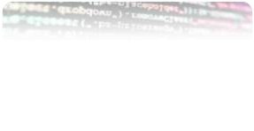


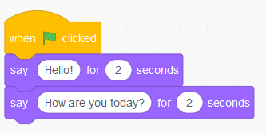
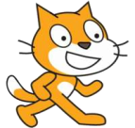
TRAINING MODULE

ON CODING FOR MIDDLE
SCHOOL TEACHERS
Centre for Mathematics, Science and
Technology Education in Africa

(CEMASTEA)

British council sponsored

ISO 9001:2015 CERTIFIED



CEMASTEA –NAIROBI, KENYA 2023

CENTRE FOR MATHEMATICS, SCIENCE AND TECHNOLOGY EDUCATION IN
AFRICA (CEMASTEA)
P. O. BOX 24214-00502 Karen – Junction of Karen Road and Bogani Road, NAIROBI –

KENYA
Tel Numbers: 020 2044406 / 0706 722697 / 0780 797648
E-mail: director@cemastea.ac.ke

Website: http//www.cemastea.ac.ke
All rights reserved © CEMASTEA, 2023

Approved for circulation

09 JUN 2023

for JACINTA AKATSA, HSC

CEO, CEMASTEA

Citation

CEMASTEA (2023). Training Module
on Coding for Middle School Teachers. CEMASTEA: Nairobi, Kenya

ISO 9001:2015 CERTIFIED

ISO 9001:2015 CERTIFIED

CBC -Competency-Based Curriculum
Acknowledgment
Acronyms and Abbreviations
CEMASTEA-Centre for Mathematics Science and Technology Education in Africa
PCIs-Pertinent and Contemporary Issues

The CEO of CEMASTEA would like to thank the following staff for their input in the
development of this module.
1. Jacinta Akatsa -CEO
2. Makoba Kizito
3. Martin Mungai
4. George Kiruja
5. Nancy Nui
6. Francis Kamau
7. Philip Maate
8. Richard Jakomanyo
9. Clotilda Nyongesa
10. Rahab Chiira
11. Agnes Mwangi
12. Dr. Njoroge Mungai
13. Clara Mwangi
14. Esther Kamenwa
15. Lucy Mwaniki
16. Paul Lomosi

ISO 9001:2015 CERTIFIED

Introduction

One of the learning areas in grades 4 and 5 is science and technology. Giving students a
foundational understanding of science and computing is essential. One of the sub-strands
in this learning area is coding. Coding proficiency is a necessary ability in today's
technologically advanced environment. It is crucial to introduce coding throughout the
early learning years because it introduces students to computational and design thinking
at a young age. In a research carried out by CEMASTEA on coding it was observed that
teachers needed support to teach coding (CEMASTEA,2022). This informed the need to
prepare materials on coding and train teachers. The module is consistent with the
requirements of the curriculum designs for grades four and five. The following topics are
covered in the module to address the proposed learning outcomes namely: an introduction
to coding; patterns and games; Overview of Scratch; Animation using Scratch; Games
and Graphics using Scratch; and Scratch Project. The interactive teaching method used in
the module gives teachers the chance to get hands-on experience with coding from the
beginning while creating numerous activities and projects.

Rationale
The Science and Technology curriculum designs for grades 4 and 5 and the baseline
study by CEMASTEA (2022) served as the foundation for the content of this module.
The creation of this module will enable teachers to acquire instruction in the
fundamentals of coding.

Theme: Enhancing teachers’ capacity to teach coding at grades 4 and 5

Expected training Outcomes
By the end of the training, the participant should be able to:
1. Identify the features of learning applications which imitate simple programming
2. Interact with patterns and games using available learning applications which
mimic simple programming
3. Identify a learning platform for creating stories, games, and animations
4. Create simple animations using applications that mimic simple programming
5. Create simple games and graphics for enjoyment
6. Use available learning applications to find solutions to problems in the local
environment

Expected training outputs:

1. A scratch project problem solving
2. A lesson to teach coding

ISO 9001:2015 CERTIFIED

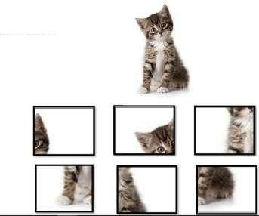
Section 1: Introduction to Coding
o

Welcome to Section One of this Module. This section will equip you with the knowledge

and strategies needed in learning coding. In today’s digital era, coding has become an

essential skill for children. To make the learning process engaging and enjoyable,
exciting activities that combine game puzzles and mazes are used to introduce the
learners to basic coding skills.

Reflection 1
Share your favorite childhood games and toys, and briefly discuss why you enjoyed.
• You will realize that it is all connected to creativity, problem solving and playfulness.

Reflection 2
Share the strategies you used to make others learn the game.
• Effective teaching strategies you may have mentioned:
o Providing clear simple instructions
o Incorporating demonstrations (Hands on activities)

Encouraging creativity and self-expression
o Offering scaffolding and guidance

All these are essential elements for coding. In
grade four, learners were exposed to codes in
a playful way. Do you think the tasks below
can help develop problem-solving skills,
logical thinking, and computational
creativity?
Perform the following tasks.

Task 1

Jig-saw puzzle;

•

Cut out the pieces and build the cat

above

•
Use the link to play the jig-saw game

https://www.jspuzzles.com/en/transportation/vehicle/truck/pickup-truck/2459888

ISO 9001:2015 CERTIFIED








Task 2

Tell your friend how to move the smiley face to the last box where the lollipops are.

Note: The smiley face can only move vertically or horizontally!

Start

Here
3
8
12

9

7

10

6

1

2

4

15

End

5

11

13
Here

Task 3

In the grid fill in the missing numbers using; 1,2,3,4. No number should be repeated

horizontally or vertically.

3

1

2

3

ISO 9001:2015 CERTIFIED

Task 4: Discussion
Discuss how Tasks 1,2 and 3 can help develop problem-solving skills and logical
thinking.

Young children are curious and enjoy exploring and experimenting. A playful approach to
coding taps into their innate sense of play and makes the learning experience enjoyable.
Creativity, logical thinking, problem-solving, and playfulness are essential elements in
coding.

What is coding?
Coding can be defined as the process of developing and implementing various sets of
instructions to enable a computer to perform a certain task, solve problems, and provide
human inter-activity (Balanskat & Engelhardt, 2014).

What is programming?
Programming is giving instructions to a computer or a device to perform specific tasks or
solve problems. It involves writing a series of step-by-step instructions called codes that
tell the computer what to do. Just like we use words to communicate with other people
we use codes to communicate with computers.

A set of rules and commands that a computer understands is known as a programming
language. There are many programming languages and coding apps available for young
learners based on age appropriateness, educational value, and user-friendliness. These
include Blockly, Swift Playgrounds, Kodable, Python, Tynker, Minecraft, Hopscotch, and
Scratch. Scratch is widely used in schools and has a large online community where
learners can share their projects.

ISO 9001:2015 CERTIFIED

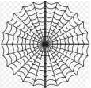




Section 2: Patterns and Games
and observe the

A computer code as defined earlier is a set of instructions that enables a computer to
perform a particular task. Similarly, a pattern that uniquely identifies something can be
referred to as a code. For example, a banana leaf has a pattern formed by the leaf veins
which is unique to all banana leaves. A spider web contains a pattern that is unique to the
type of spider making the web and so are nests of birds. All these are natural codes.

Spider web Banana leaf Weaver nest

Activity
Click the link https://scratch.mit.edu/projects/394885714/fullscreen/

animation. Describe your observation.

a) Games and animations
In this section, we are going to play games or use animations created with scratch
applications. The following shows examples of animations and games created using
scratch.
Click the link {my_story.sb3} to view an animation created using a coding application.
Once clicked you will see a page as shown below:
Click the full control icon to maximize the image. Once the image is full screen click the

green flag icon
observation.

to play the animation. Observe what happens and describe your

ISO 9001:2015 CERTIFIED

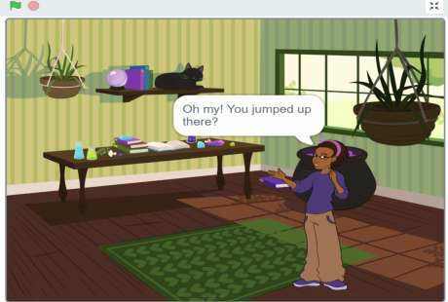
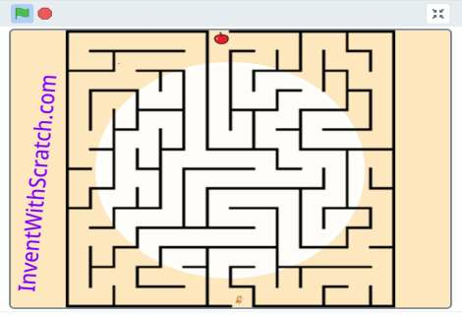
Animated story

Click the link https://scratch.mit.edu/projects/11710850/editor/

You will access a maze. Maximize the maze so that it fills the page by clicking the full
control icon. Click the green flag and use the arrow keys (for a laptop) to move the sprite
(Cat icon) to the apple. For a smartphone or tablet you can drag and navigate the icon
along the maze all the way to the apple.

Maze game

ISO 9001:2015 CERTIFIED


Section 3: Overview of Scratch

What is Scratch?

Scratch is a visual programming language that allows learners to create their own
interactive stories, games, and animations. As the learners design their own projects in
Scratch, they develop the skills of thinking creatively, reasoning systematically, and
working collaboratively.
https://www.uab.edu/icac/images/Scratch_Guides/Intro_to_Scratch.pdf

Definition of terms as used in Scratch

a) Interface - Scratch software

b) Programming - the process of creating sets of instructions or commands that tell a
computer what to do.

c) Coding - refers to the process of writing instructions or commands in logical and
sequential steps known as codes that a computer can understand and execute.

d) Code blocks - puzzle-piece-like shapes which represent a set of commands that
instruct the computer on the task to be performed by the character in the story.

e) Sprite - the main character(s) in the story created. They can be made to move around,
change the appearance or even react when they touch something.

f) Animation - display of a sequence of images of the sprite which create an illusion of
movement

g) Gaming - the art of creating a game in Scratch

h) Backdrops - background displaying the scene of the character(s) in the story.

i) Project - story/game created in Scratch

j) Costume - A costume is a different appearance for the same sprite allowing a sprite

being controlled by one or more scripts to appear to change its looks.

Getting started with Scratch
Double click on the Scratch icon to get started.

ISO 9001:2015 CERTIFIED

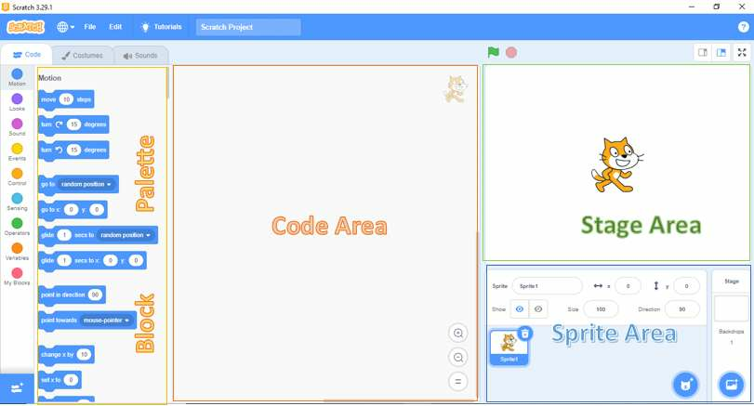
This brings you to the interface home page which has 4 main elements namely;
1. Block Palette - also known as the programming palette
2. Code area - also known as the scripting area
3. Stage area
4. Sprite area

.

Block palette: This contains instruction blocks (code blocks) used to program the sprite
to do or say something.

Coding area: This is the space where the code blocks are dragged and dropped as you
write a program(story/games).

Sprite area: This is the area or space where the selected sprites appear and can be
interchangeably controlled for display in the coding area. It defines the boundaries within
which the sprite can move and interact with other objects. It is represented by a
rectangular shape that encloses the sprite's image or costume

Stage: This is the primary area where the action of the program is displayed as performed
by the sprite. The stage may be of different backgrounds.

ISO 9001:2015 CERTIFIED

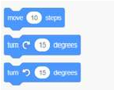
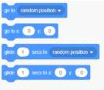
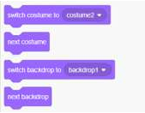
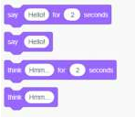
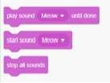
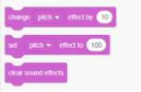
The code blocks
In writing a program, a set of commands is used to instruct the computer how to perform
a certain task or how to solve a certain problem. This is done by typing the commands.
However, in Scratch, code blocks are used to represent these commands. These code
blocks are represented by colorful puzzle-piece-like shapes that fit together to create a
script or program. The code blocks have notches at the top and bumps on the bottom.
To create a story/game/animation, you need to stack the blocks in the appropriate order.
This is done by dragging a code block from the appropriate category in the block palette
and dropping it in the coding area as you build a set of commands for the
story/game/animation. The categories include motion, looks, sound, events, and control
among others. Examples of these code blocks in these categories are given below.

Motion Blocks:
These blocks in Scratch are used to move or turn sprites around the stage. For example:

Looks Blocks:
These code blocks are used for the purpose of controlling a sprite’s appearance (size,

costume, or visibility). They are also used to add speech bubbles and change the
backdrop.

Sound Blocks:

These code blocks are useful in adding music and sound effects. For example,

ISO 9001:2015 CERTIFIED

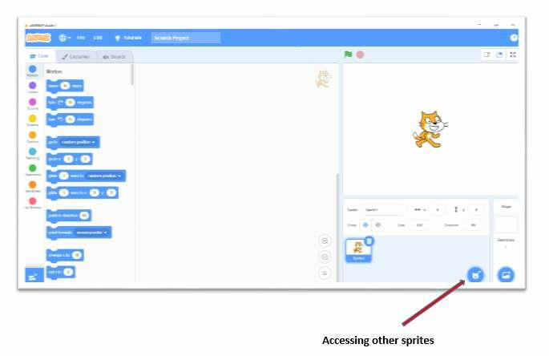
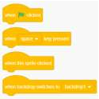
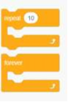
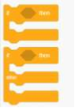
Event Blocks:
These are the most important code blocks in Scratch. These blocks are used to start the
code. They always come at the beginning of the code.
For example, when the green flag is clicked block.

Control Blocks:
Control blocks are used in Scratch to give certain conditions. Some of the commonly
used control blocks are as shown below.
Repeat Blocks and If then else Block:

Accessing other sprites from the interface
A story may have more than one sprite. Scratch provides a library of sprites from which
other sprites can be accessed. To change or add the sprites, you can select a different
sprite from the library or you can create your own. This is done by clicking on the
"Choose a Sprite from Library" button located below the stage area.

ISO 9001:2015 CERTIFIED

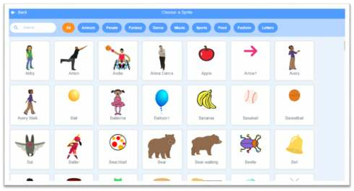
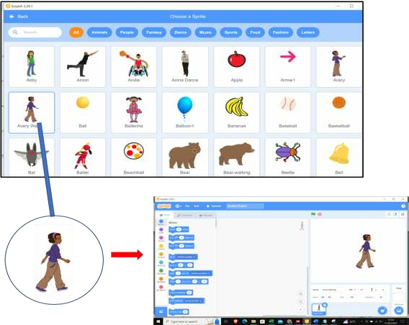
Browse the sprite library: In the Sprite library, you'll find various categories and options.
You can choose from.

For example, we can select the sprite as indicated in the diagram below and see how it
changes on the stage area.

ISO 9001:2015 CERTIFIED

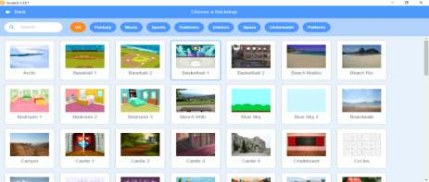
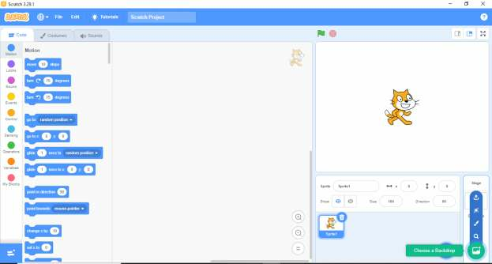
Changing Backdrops on the scratch interface.

In Scratch, a backdrop is an image that can be shown on the stage. Scratch provides a
variety of options for backdrops. To change or add a new backdrop we click on the

“choose a backdrop’ button on the bottom right corner of the sprite area.

Browse the Backdrop library: In the backdrop library, you'll find various categories and

options. You can choose from

ISO 9001:2015 CERTIFIED

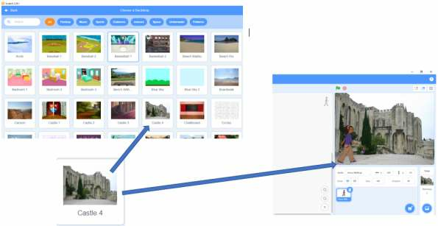
For example, we can select a backdrop as shown below and see how it changes in the

stage area

Activity 1
a) Using the ‘choose a sprite’ icon, select a different sprite of your choice for your

project.

b) Select an appropriate backdrop for your sprite in (a)

ISO 9001:2015 CERTIFIED

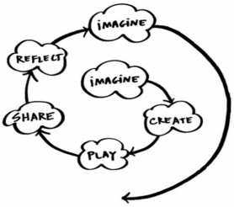
Section 4: Animation using Scratch
imagining
of
consists
Storyboarding
process of creating an animation by
• The
• Animations

Introduction

Welcome to animation in sscratch. In this section, we will focus on how to animate and
create an animated project based on pertinent and contemporary issues (PCIs).

Reflection
1. What is animation?
2. What are some of the area where animations are applicable?
You may have come up with the following;

•
Animation is the process of manipulating still figures (sprites in scratch) to create
the illusion of movement. In scratch programming, sprites (icons) are manipulated
to create a combination of live action.

are applied in various areas such as; education, entertainment and
gaming, advertisement and marketing, architecture and engineering.

• Animation can be applied to facilitate learners’ understanding of various aspects

outlined in the Competence Based Curriculum (CBC), such as Pertinent and
Contemporary Issues (PCIs).

learners can harness the core
competencies, such as creativity and imagination.

How to animate
Animation in scratch programming can be summarized
into two major steps.

I.
and
creating a series of actions to be illustrated by
the sprite.

II. Programming
actions.
the
sprites
to
illustrate
the

Figure 1 indicates the spiral of creative learning by
Resnick (2007), which shows the interaction between
the two steps.

Figure 1: The spiral of creative learning
"The kindergarten approach to learning"
(Resnick, 2007).

ISO 9001:2015 CERTIFIED

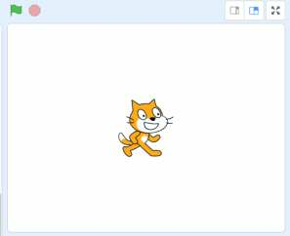
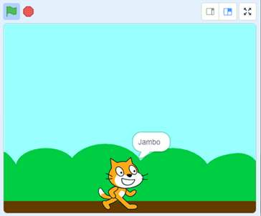
The following is an example of animation based on the two steps.
move around on a blank backdrop
turn and Jump

Imagine

Reflection

● Imagine the actions you want your sprite to perform?

In Scratch the default sprite is a cat . We are going to animate the cat to talk and
move around the screen using the ‘move’ code block and ‘say’ code block. The cat sprite

is usually on a blank backdrop (background), we will change and have the cat move
around a new backdrop by introducing a ‘go-to’ code block. Next we will make the cat
jump for a specific number of times by introducing a new code block known as ‘repeat’
code block.

At this point we will save the existing project before introducing a second sprite known
as ‘Avery Walking’ .We will reposition, turn and resize ‘Avery Walking’ and let her
take a walk with ‘the cat’ as they chat. This will include the use of ‘show’ and ‘hide’
code blocks. Let us now apply visuals to the imaginations on a storyboard.

Make the Sprite cat to say ‘Jambo’ and

Change the backdrop and make the cat to

ISO 9001:2015 CERTIFIED

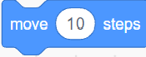

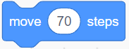
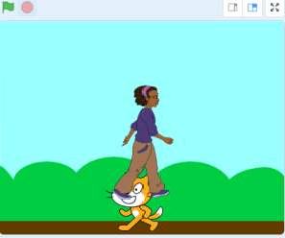
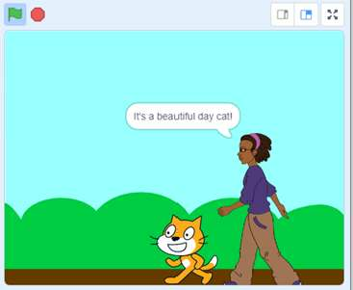


Introduce the second sprite- “Avery
walking”
Turn and increase the size of Avery. The
two sprites take a walk as they chat.

Create
Reflection
● How do you animate the sprites based on the imagination above?

This involves writing commands to actualize the intended action as outlined on the
storyboard. The commands can be adjusted to reflect changes made progressively on the
storyboard.

Step 1: Make the Sprite cat to say ‘Jambo’ and move around on a blank backdrop

Open Scratch by double-clicking on the scratch icon on the computer's desktop.

On the left-hand side of the Scratch interface in the Blocks palette section, click on the
Event category

Drag and drop the following code block into the Script Area.

Click on the Motion category

Drag and drop the ‘move’ code block on the script area

Click inside the text area written ‘10’ steps and change the number of steps to ‘70’

ISO 9001:2015 CERTIFIED


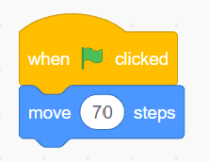
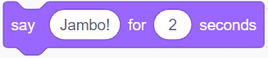
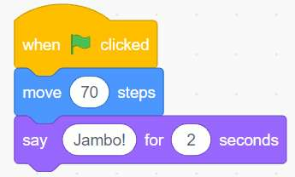
Attach the ‘move’ code block to the previous ‘when-clicked’ the command block as

shown below.

Next, click on the Looks category

Drag and drop on the Script Area the command that says Hello for two seconds. Replace
the word ‘Hello!’ with ‘Jambo!’

Attach the block to the previous two block commands as shown below

Click the Green Flag
happens to the cat sprite.

on the top left-hand side of the screen and observe what

ISO 9001:2015 CERTIFIED


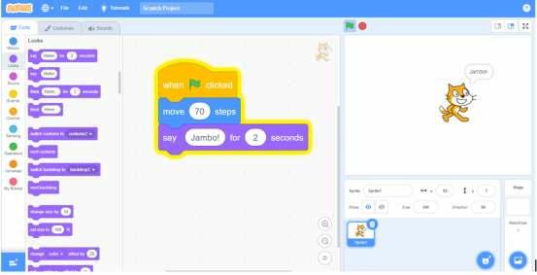
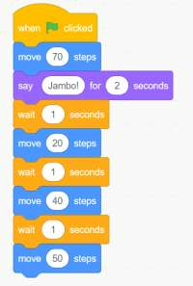

In order to create the illusion of the cat walking and to increase the sprite's movement we

will use the ‘wait’ block.

Click on the Events category

Drag and drop the ‘wait’ code block and attach to existing code block

Drag and drop three more ‘move’ code blocks and adjust the number of steps to 20, 40,
and 50 as shown in the code block below.

ISO 9001:2015 CERTIFIED


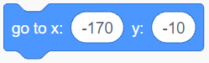
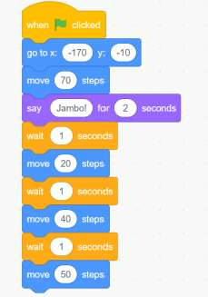
After adding more move code blocks, you will notice the cat will keep on moving until

it's almost at the edge of the stage. To avoid the sprite disappearing off the stage, we will

add one last code block, the ‘go-to’ code block.

Click on the motion category

Drag and drop the ‘go-to’ code block on the script area

The code block has different X and Y coordinates depending on the position of ‘the cat’

on the stage. It allows one to position the sprite at different points on the stage.

The stage is partitioned into two sets of coordinates: the X-axis represents the horizontal

position, and the Y-axis represents the vertical position.

Move ‘the’ cat randomly to different positions on the stage and observe how the X and Y

coordinate change on the block palette.

Add the ‘go-to’ code block after the ‘when-clicked’ code block to bring the cat back to

the point of preference on the stage area.

ISO 9001:2015 CERTIFIED

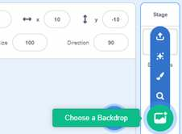
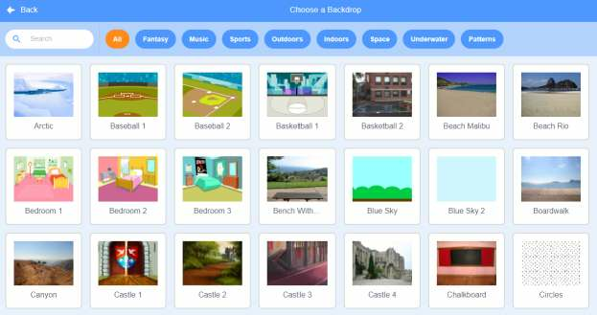
Click the Green Flag on the top left-hand side of the screen and observe what happens to
the cat sprite.

Step 2: Change the backdrop and make the cat to turn and Jump

Go to stage at the bottom left and click on the new Backdrops icon located under the
Stage icon

Click on the Blue-Sky backdrop

Click on the green flag and observe what happens

ISO 9001:2015 CERTIFIED

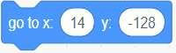

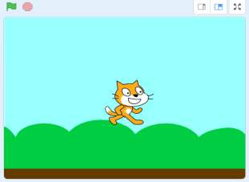
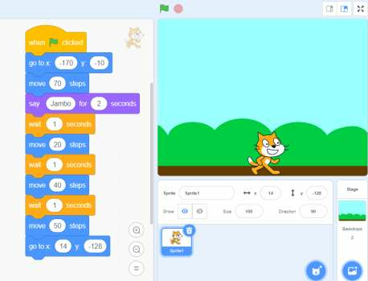
‘The cat’ seems to be floating above the new backdrop.

Drag and drop the ‘go-to’ code block on the script area to place the cat on the ground

‘The cat’ will now be positioned at the bottom of the backdrop.

Now let's make ‘the cat’ to turn then jump up and down

ISO 9001:2015 CERTIFIED

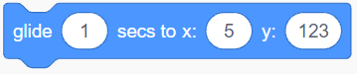


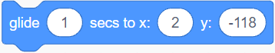

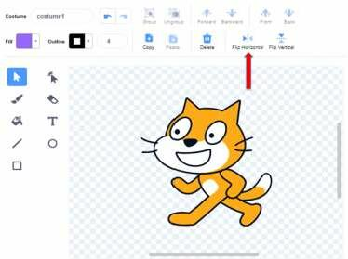
Click on the costume tab

Click on the Flip Horizontal tab

The cat will turn to face the opposite direction as shown below.

Click on the code tab to go back to the coding area

Move ‘the cat’ sprite at the top of the stage area. The X and Y coordinate will change

accordingly as observed in the motion area.

Drag and drop the ‘glide’ code block on the script area.

An example code would look like this

Move ‘the cat’ sprite at the bottom of the stage area. The X and Y coordinate will change

accordingly as observed in the motion area.

An example code would look like this

Note the Y coordinate has changed to a negative. Click on the green flag and observe

what happens

To make the cat jump up for a specific number of times, click on the Control category

ISO 9001:2015 CERTIFIED

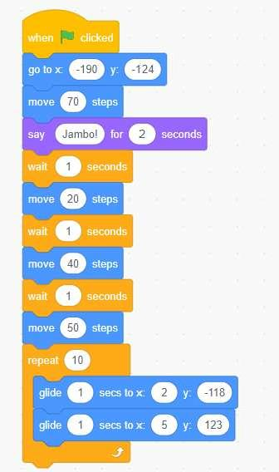
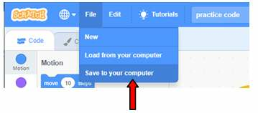
Drag and drop the ‘repeat’ code block to the existing code blocks such that the ‘glide’

code blocks are enclosed as shown.

Let’s now save our project. Click on the file menu at the top right of the screen

On the drop down menu, click on Save to your computer

On the left-hand side of the dialog box, choose the location to save your project in this
case, the Desktop.

Click on the Desktop option and create a folder named My Projects.

ISO 9001:2015 CERTIFIED



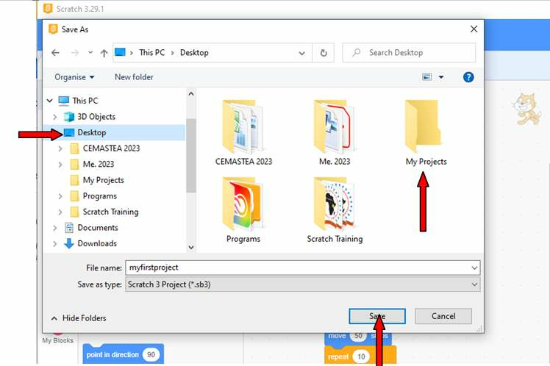
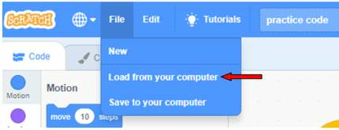
Double click on the folder My Project to open.

Place the cursor in the File name input box and key in the file name myfirstproject

Click on the Save button

Step 3: Introduce the second sprite- “Avery walking”

Click on the file menu at the top right of the screen to open the project we were working

on in the previous section myfirstproject.

On the drop down menu, click on Load from your computer

A dialog box will appear, click on the desktop and locate your folder My Projects

ISO 9001:2015 CERTIFIED


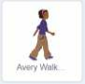
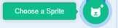
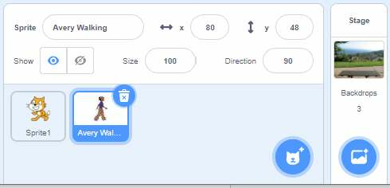

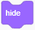
Select your project named myfirstproject and click open.

To introduce a new sprite, click on the Choose a Sprite icon

Click on the ‘Avery Walking’ Sprite

The ‘Avery Walking’ icon is highlighted in blue, showing that the Sprite is active.

Let us now code ‘the cat’ to take a walk with ‘Avery Walking’ as they have a chat.

On the block section click on Events category

Drag and drop the ‘when- clicked’ block code in the Script area.

On the Looks category, we have the ‘show’ and ‘hide’ code blocks.

These code blocks will hide ‘Avery Walking’ so that she appears on the stage after ‘the

cat’ has completed its jumps.

Add a ‘wait’ code block to input the number of seconds ‘Avery Walking’ will wait before

appearing. The number of seconds depends on how long ‘the cat’ code program takes.

The code will look something like this:

ISO 9001:2015 CERTIFIED

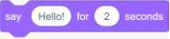

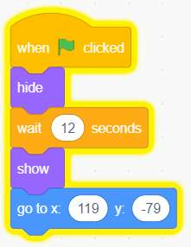
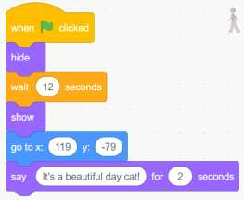
Activity

1. ‘Avery Walking’ will appear as if she is floating, add the X & Y coordinate block

to place her on the ground.

2. Turn ‘Avery Walking’ to face the same direction as the cat.

Now let's get Avery to say “it’s a beautiful day cat!’

While still on code for ‘Avery Walking’, click on the Looks category.

Drag and drop the code block

Click in the input box and change from ‘Hello!’ To ‘It's a beautiful day cat!’

Click the Green Flag on the top left-hand side of the screen and observe what happens.

Add a code where ‘the cat’ will respond with a ‘purr!’

ISO 9001:2015 CERTIFIED

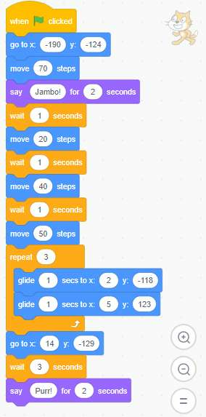
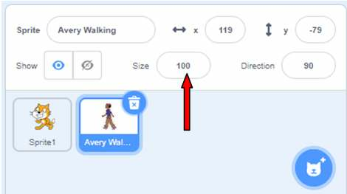
Step 4: Turn and increase the size of ‘Avery Walking’. Make ‘Avery Walking’ with

‘the cat’ take a walk as they chat.

On the Sprite List section, click on the ‘Avery Walking’ icon to activate it

Click on the Size input box. Change from 100 to 120. Observe what happens.

ISO 9001:2015 CERTIFIED

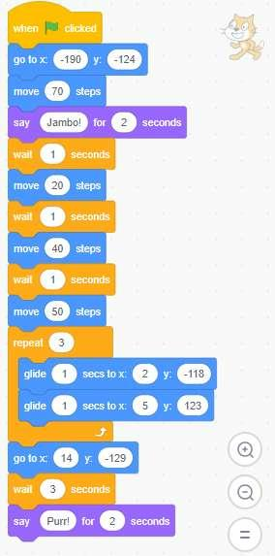
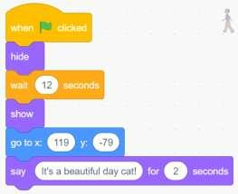
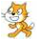
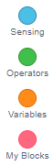
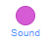

Activity
and ‘

Build up ‘Avery Walking’ and ‘the cat’ code blocks to make them walk as they talk.

Final code for Sprite 1: CAT

AVERY WALKING’

Play with the creations

We will be clicking the Green Flag on the top left-hand side of the screen and observe

what happens to the animation we have created.

It involves a process of trial and error. Explore and test boundaries of

animation by;

● Change the sprites and backdrop

● Make the sprite glide in different directions

● Add a third sprite and animate it as you like

● Continue the conversation between Avery and the cat.

●
Trying out different codes blocks

ISO 9001:2015 CERTIFIED

Share the ideas and creations with others
●
●
●

We will share our ideas on;

● The changes we have made to the sprites and backdrop

● The reason making the changes

● Additional code blocks that you might have used.

Reflect on the experiences of animating.

Imagine new animation ideas and project to do

We will come up with new animation ideas by drafting a storyboard

Project task

Create a storyboarding on any of the following Pertinent and Contemporary Issues (PCIs)

for animation:

1. Climate change

2. Affordable housing

3. Care for the environment and animals

Or any other of your choice

Additional Learning Resources

The following two links can be used to support learners on the CBC sub-strands on care
for the environment and animals.

●
Tree simulator: https://youtu.be/St244bVXC-c

How to make a virtual pet: https://youtu.be/irhNLRWwhv0

The following are introductory links to animation through scratch programming.

●
Create animation with scratch https://youtu.be/1GmaQAQvgPc

How to make animation in scratch programming: https://youtu.be/k4zMuBf-7Vs

How to make a jumping game in scratch: https://youtu.be/1jHvXakt1qw

ISO 9001:2015 CERTIFIED

Section 5: Games and Graphics Using Scratch

Introduction
Scratch games promotes learner’s computational thinking, creativity, and problem solving

skills. Further, it promotes communication and collaboration as learners work in groups.
Learners can use Scratch to create their own stories, games, and animations, and share
with others. Scratch introduces the learners programming.

Scratch enhances learner’s high order thinking skills as they come up with creative

solutions to problems. Coding enables learners to figure out how to break down complex
ideas into smaller manageable parts. As learners make games, animations, or stories, they
have to figure out how various parts of their coding can work together. This develops

their problem-solving skills that can be applied to other areas of their daily life.

Imagine
We are going to create a maze game using scratch application. First we will sketch on a
piece of paper a maze with a clear path from start to exit. We will use the sketch to draw
the maze on a canvas on scratch application with the help of your mouse pointer.

We will code two sprites; a Sprite 1 the cat and a packet of milk. The goal is to make the

‘cat’ sprite move along a path in the maze till it reaches the ‘milk’ sprite. For this game
we wanted the ‘Milk’ to make a sound when ‘Sprite 1’ touches ‘milk’. The code block to

use will include the Motion, Looks, Sound, Control, Sensing and Events.

The sensing blocks will be used to tell or highlight how sprites interact with their
surroundings. The broadcast block will broadcast messages to let one part of the code or
project communicate with another part. An if-then block code will be used to ensure that
the sprite only uses the designated path to the milk. A forever code block will be used to
repeat the sequence of commands to ensure the continuity of the game.

Create
Let’s now create the maze and code the maze game.
1. How create the maze
On a piece of paper sketch a maze with a clear path from start to exit.

ISO 9001:2015 CERTIFIED

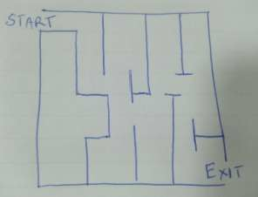
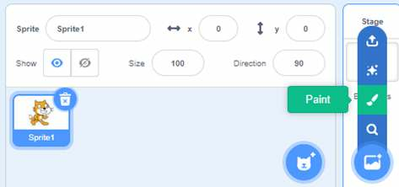
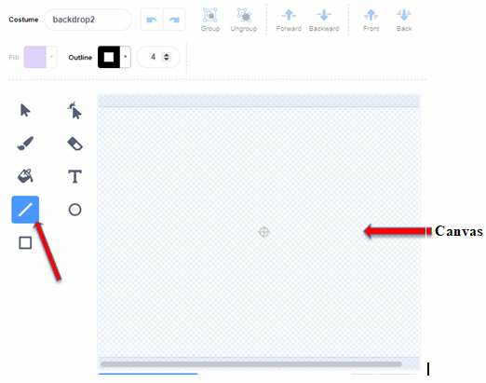
Open the scratch application

On the bottom right corner click on the paintbrush on the pop up menu.

Select the line icon highlighted in blue

ISO 9001:2015 CERTIFIED



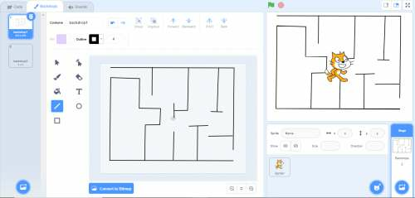
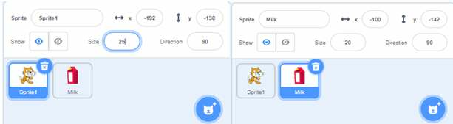
Draw your maze on the canvas with the help of your mouse pointer. As you draw, your
maze will appear as a backdrop

2. How to create a maze game

Click on the code button to start creating the game

Remember in Scratch the default sprite is a cat. Choose the second sprite ‘Milk’

Change the size of the Sprite 1 to 25 and Milk 20

Coding Sprite 1: the cat

Click on ‘the cat’ Sprite

Change the sprites position using x and y coordinates for the sprite to move in the
different directions

a. Right arrow

ISO 9001:2015 CERTIFIED



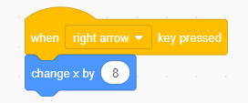
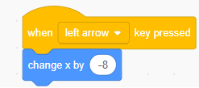
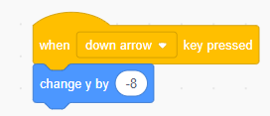
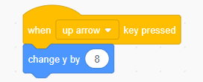

b. Left arrow

c. Down arrow

d. Up arrow

Drag and drop the following block into the Script Area.

Drag and drop on the Script Area the command that says Hello for two seconds. Replace
the word ‘Hello!’ with ‘I need milk!’

Add the ‘wait until- touching’ code Block

ISO 9001:2015 CERTIFIED



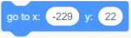
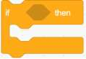
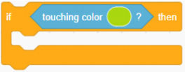
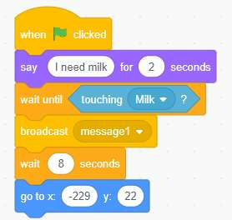
This code gives a condition, ‘the cat’ only goes on after it touches ‘Milk’

Click on the Control category

Drag and drop the ‘broadcast’ code block

Add the ‘wait’ code block and change it to 8 seconds

Drag and drop the ‘go-to’ code block on the script area

Click the Green Flag on the top left-hand side of the screen and observe what happens.

Activity: Can you tell what ‘the cat’ is expected to do from the following code?

Drag and drop a second ‘when- clicked’ block into the Script Area

Add the ‘if-then’ code block

Drag and drop the ‘touching color’ code block on the ‘if-then’ code block

ISO 9001:2015 CERTIFIED

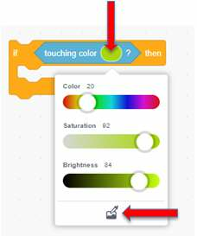
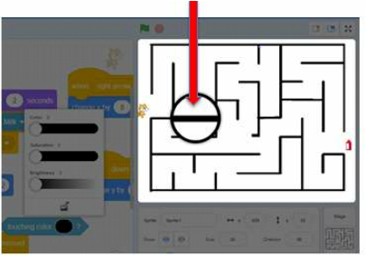
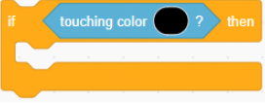
Click on the color, a drop down menu will appear.

At the bottom of the color code, click on the paint icon.

Move the mouse cursor on the maze. A magnifying glass will appear, click on any line of

the maze. The color on the code will change to reflect the color of the maze.

ISO 9001:2015 CERTIFIED

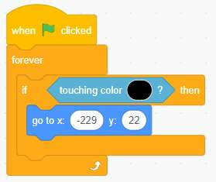
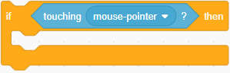
Drag and drop the ‘go to x: y’ code block inside the ‘if-then’ code block. This will take

the cat back to the starting point when it touches the boundaries/line of the maze.

Drag and drop the ‘forever’ code block to encapsulate the ‘if-then’ code block

Click the Green Flag on the top left-hand side of the screen and observe what happens.

Let's add one more condition to control the use of a mouse pointer.

Drag and drop a third ‘when- clicked’ block into the Script Area

Add the ‘if-then’ code block

Drag and drop the ‘touching mouse-pointer’ code block on the ‘if-then’ code block

Drag and drop the ‘go to x: y’ code block inside the ‘if-then’ code block. This will
restrict moving ‘the cat’ using a mouse pointer.

Insert the ‘forever’ code block inside the ‘if-then’ code block

ISO 9001:2015 CERTIFIED




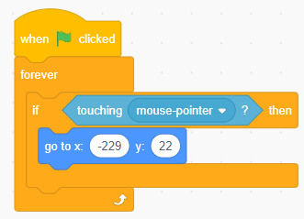
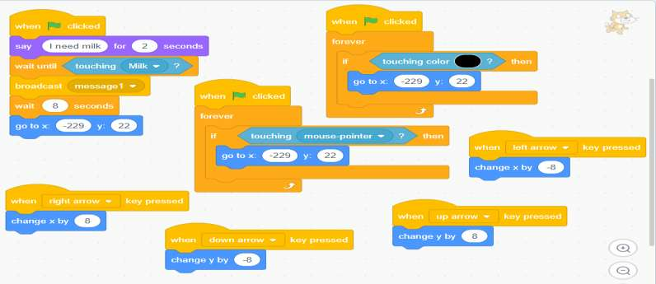
Final code should look something like this:

Coding ‘Milk’ sprite

Click on the ‘Milk’ sprite to highlight and code it.

Drag and drop a second ‘when I receive’ code block into the Script Area

Attach an anticlockwise ‘turn degrees’ code block

Click on the sound category

ISO 9001:2015 CERTIFIED



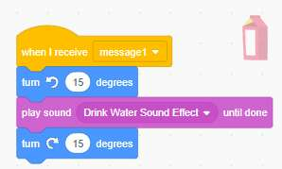
Drag and drop the play sound-until done code block

Attach a clockwise ‘turn degrees’ code block

Click the Green Flag on the top left-hand side of the screen and observe what happens.

Final code should look something like this:

Now let’s Play with the game, explore and test the boundaries of the game.

Share the ideas about the game with others;

● What was good about the game

● The challenges faced when coding

●
Areas of improvement

Reflect on the experiences of coding a game in scratch.

Project task

Imagine new game ideas you can create. Draft the ideas in a storyboard then create a
game on any of the Pertinent and Contemporary Issues (PCIs)

Suggestions:

● Equality Puzzle: Design a puzzle game that promotes diversity and inclusion.

●
Food Waste Challenge: Create a game that educates players about the issue of food

waste.

ISO 9001:2015 CERTIFIED

● Cybersecurity Defender: Design a game where players take on the role of a

cybersecurity expert defending a virtual network from cyber threats.

●
Climate Challenge: Create a game where players must navigate a world affected

by climate change.

ISO 9001:2015 CERTIFIED

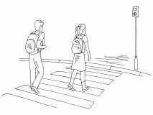
Scratch Project
c.

In this section we are going to discuss how to use scratch to find a solution to a problem
in your local environment.

Example
A primary school is located along a busy highway.
Learners cross this road to access the school in
the morning and in the evening while going
home. The problem is how to guarantee the safety
of learners while crossing the busy highway.

Solution

Safety rules/ steps that learners can follow while crossing the road.

Steps/ rules that learners can follow:

a. Move to the road edge and stop
b. Check left, right and left again before crossing

Look around while crossing to spot any oncoming car or motorbike
d. If the road is clear, then cross.

Trial code to solve the problem using paper

Manila papers can be used to form blocks labeled with instructions that will be used to
solve the problem. The instructions need to be arranged in a logical manner as follows:

MOVE TO THE ROAD

STOP AT THE ROAD EDGE

CHECK LEFT

CHECK RIGHT

CHECK LEFT AGAIN

MOVE TO CROSS

Solving the problem using scratch
The paper blocks with instructions to solve the problem can be used to form code blocks
on the scratch. The codes should have atleast one block from

ISO 9001:2015 CERTIFIED

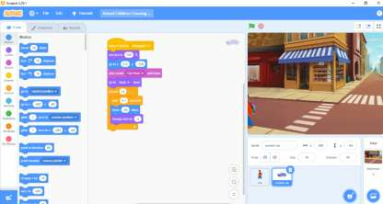
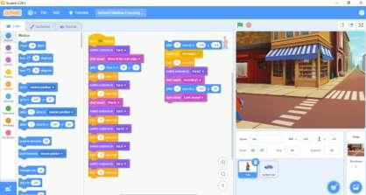
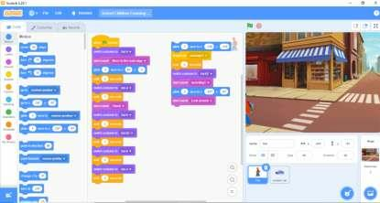
the motion, looks, sound, events and control button. The code blocks should be
dragged to the code area and arranged in a logical manner as follows:

Activity 1
a) In groups discuss and name one problem found in your environment.
b) In your note books, write, draw, and describe how you will solve the problem.

ISO 9001:2015 CERTIFIED

c) Using Manila paper and scissors cut out all the blocks needed to solve your probl
em.
d) Label them with the instructions you will use to solve your problem.
e) Arrange them in a logical manner.
f) Draw your arrangement in your notebook

Activity 2
Solving your problem with scratch
In the previous activity, you identified a problem and came up with a solution, you then drew
code blocks needed to solve the problem.
a) Using your drawings, find the code blocks on scratch and drag them to the code
area.
b) Your code should have at least one block from the Motion, looks, sound, events
and control button
Arrange your code blocks in a logical way and make any changes you need to m
ake.

ISO 9001:2015 CERTIFIED

Conclusion
and
be part of the online community on the scratch platform to showcase your learner’s
projects as well as learn from others in the global community.

The teaching and learning of coding undoubtedly promote several CBC fundamental
skills, such as problem-solving, communication, and collaboration. Coding encourages
student cooperation, creativity, and problem-solving abilities. Furthermore, coding has
demonstrated efficacy in teaching fundamental programming ideas as well as promoting
computational thinking nd learning.In this module the focus was on developing coding
skills uisng Scratch application.

Scratch is a programming language developed by the Lifelong Kindergarten Group at the
MIT Media Lab. It is designed to teach children the basics of programming through a
visual interface. Scratch allows users to create interactive stories, games, and animations
by dragging and dropping blocks of code. For teachers in Grade 5, we have seen how
Scratch can be a valuable tool for introducing students to the world of coding. By using
Scratch, teachers can engage students in a fun and interactive way, while also teaching
them important coding concepts. You are encouraged to join https://scratch.mit.edu/

We hope that this module had enabled you to improve your efficacy to teach codingto
your learnrs.

ISO 9001:2015 CERTIFIED

References
st

Resnick, M., Maloney, J., Monroy-Hernández, A., Rusk, N., Eastmond, E., Brennan,
K., ... & Kafai, Y. (2009). Scratch: programming for all. Communications of the
ACM, 52(11), 60-67.

Balanskat, Anja, and Katja Engelhardt. 2014. Computing Our Future: Computer

Programming and Coding-Priorities, School Curricula and Initiatives across

Europe. European Schoolnet.

World bank 2019. Chidren learning to code: Essential for 21 Century Human Capital

ISO 9001:2015 CERTIFIED

ISO 9001:2015 CERTIFIED

