

**STATUS REPORT ON PLANNING/ PREPARATION OF PROJECT ON TRAINING PUBLIC PRIMARY SCHOOL TEACHERS ON CODING**

1. **INTRODUCTION**

A project team appointed by the CEO, CEMASTEA has been convening since early January, 2024 to plan and prepare for the proposed project to train public primary school teachers on coding. The project is proposed in the background of the educational reforms with priority focus on 21st century skills including digital literacy among learners.

The project team members were allocated various tasks as follows:

| **Team** | **Task** |
| --- | --- |
| **Dr. MMacharia**, GKiruja, TKaranja, CMurambi, BMwangi | Design work plan & Training Model |
| **MMungai**, MSichangi, AMumbi | Prepare criteria & Selection of Target counties |
| **NNui**, MKizito, AMwangi, RChiira, WMagu | Prepare criteria & Selection of teachers & pedagogical leaders |
| **PKogolla**, GKiruja, WChepkirui, BKimweli | Prepare/receive letter to/ from TSC & other agencies working with CEMASTEA |

This is a status report on what has been achieved so far:

1. **WORK PLAN**

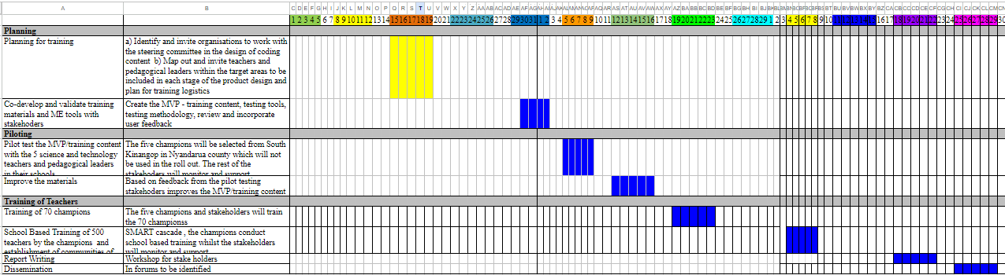

1. **CRITERIA & SELECTION OF TARGET COUNTIES**

Identifying hard-to-reach areas in Kenya in terms of technology involves considering various parameters. Here are some key factors used:

***Connectivity. Infrastructure, Electricity Access, Education and Digital Literacy, Infrastructure Development, Economic Conditions, Geographical Challenges, Government Initiatives, Cultural and Social Factors, Communication Networks.***

The following areas are deemed as hard to reach areas.

| **Region** | **County** | **Sub-counties** | **Remarks** |
| --- | --- | --- | --- |
| North Eastern | Wajir | Wajir North / Wajir East / Habasweni | Majority of population live below the poverty line, poor infrastructure, geographical challenges and poor communication networks |
| Rift Valley | Samburu | Samburu North / Samburu Central |
| Nyanza | Kisii | Nyaribari Masaba / Nyaribari Chache |
| Western | Bungoma | Tongaren – Bungoma North & Bumula |
| Central | Nyandarua | Ndaragwa / Aberdare / Mirangiine |

**Pilot Area**

Nyandarua County, specifically Kinangop Sub-county, was selected for piloting on the training of coding to teachers in middle school. This will be influenced by various factors based on a combination of educational, economic, and demographic considerations. However, this sub-county will only be used for pilot.

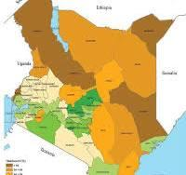

1. **CRITERIA & SELECTION OF TEACHERS AND PEDAGOGICAL LEADERS**

The target group will be primary school teachers from selected five (5) hard-to-reach counties.

**4.1 Teachers**

A total of 600 science and technology teachers from the counties will be target. Special attention will be given to SNE schools and female teachers). The following criteria will be used during selection:

1. **Have basic ICT skills**
2. **A TSC employee**
3. **Techno-savvy**
4. **Each county will select 120 teachers for the training**
5. **One to two teachers per school in regular schools**
6. **Include 2 to 5 teachers from SNE schools in the selected county. If the sub county doesn't have an SNE school/s, select schools from any other sub county within the county**
7. **Ensure a balance /almost between males and females**

**4.2 Pedagogical leaders**

A total of 170 pedagogical leaders and 370 school leaders will be targeted. Each county will select 34 pedagogical leaders and 74 HOI. The following criteria will be used during selection:

1. **A TSC employee**
2. **A HOI of a school of the teachers considered for the training**
3. **A CSOs in the area of the school of the selected teacher/s**
4. **Sub County director/s of the selected sub county**
5. **QASO of the selected sub county**

**4.3 Champions (70)**

A total of 70 champions will be selected. Each county will select 14 champions

1. **Have ICT skills**
2. **A TSC employee**
3. **Techno-savvy**
4. **Ensure a balance /almost between males and females**
5. **County trainers will be prioritised**
6. **CONCLUSION**

The information provided above is subject to change and adjustments as deemed necessary as preparations are ongoing