Lesson Plan Agriculture and Nutrition
Strand: Conservation of resources
Sub Strand: Water harvesting and storage
Specific Learning Outcomes:
By the end of the lesson the learner should be able to:
- Identify different methods of water storage for domestic use.
- Demonstrate how to store rainwater at home for domestic use.
- Appreciate the various methods of storing water for domestic use
Key Inquiry Questions: How can we store water for domestic use?
Learning Resources:
Photographs of various water storage methods for domestic use, ICT tools (laptop, phone and internet), storing cans
Organization of Learning: The lesson will be conducted in the classroom and the learners will be organised in pairs and later in groups of five.
Introduction:
The teacher asks the learners to pair and discuss how they store water in their homes.
Lesson Development:
Step 1
Learners are put in groups and provided with photos of different water storage methods. Learners observe and describe the various water storage methods in the photos provided. (NB: Teachers to describe the photos in details for the learners with visual impairment, models of water tanks can be used for the learners to explore)
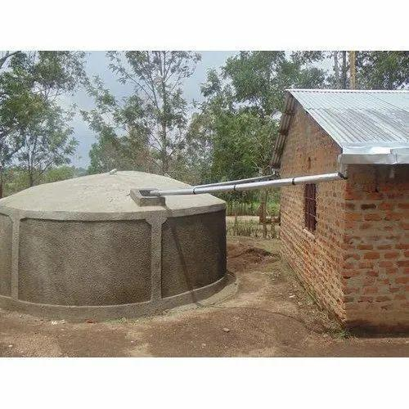a | 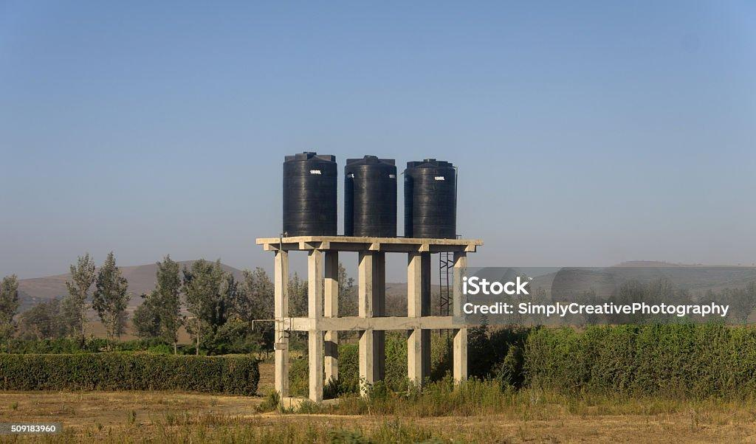 b | 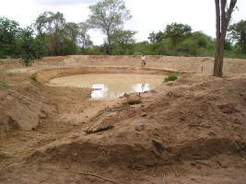 c

(Core competence: communication and collaboration as learners work in pairs/groups:
Values: Unity as learners work in pairs/groups and PCI: Social justice as learners share items fairly)
Step 2
Learners present their group work findings on various water storage methods.
The teacher harmonises the presentations using the learners’ ideas.
(Core competence: communication and collaboration as learners work in pairs/groups:
Value: Unity as learners work in pairs/groups, Responsibility as learners share roles during the group activity: PCI: Social justice as learners share items fairly)
Step 3
Learners use the ICT devices to search the internet for more water storage methods that they can use at home and discuss their findings in pairs and share.
(Core competence: communication and collaboration, digital literacy Values: respect, responsibility: PCI: Environmental conservation as learners learn how to harvest and store rainwater in the school and home environment)
Step 4
Learners ideas are used to summarise the various methods of water storage e.g shallow water pans, ponds and tanks.
Conclusion:
The learners sing a song about “rain”.
Extended Activities:
Learners take photos of different water storage facilities in their locality (school or home) and bring them to school for sharing and filling in the portfolio.
Reflection on the lesson:
The learner was able to demonstrate methods of storing water for domestic use.
Assessment
Three oral questions on harvesting water will be asked during the lesson.
The learner is asked to draw/ describe a water tank.
Learners are asked to describe any method of harvesting and storing of water they are familiar with in two hundred words and submit for marking in two days' time.

